
Guidance

The calculation policy is divided into four sections: addition, subtraction, multiplication and division. At the start of each section, you will find an overview of the progression of skills. Calculations involving decimal numbers and fractions are included.
The calculation policy follows the same concrete, pictorial, abstract approach as our main schemes of learning. Where appropriate, sentence stems and key questions are included alongside the key representations.
Where skills are divided into more than one section across the page, there is a progression in the level of difficulty from left to right.
For example, when adding across a 10, children need to be able to add across 10 itself, before making links with related facts.

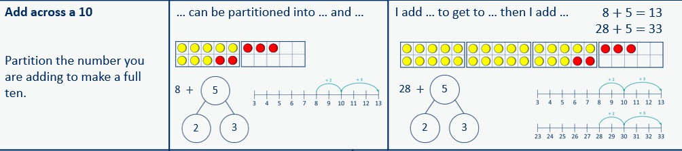
©White Rose Education 2024 2

Progression of skills - Addition

Year group | Skill
Reception | - Conceptually subitise to 5  - 1 more  - Notice the composition of numbers within 10  - Combine 2 groups  - Add more
Year 1 | - Add together  - Add more  - Bonds within 10  - Related facts within 20  - Missing numbers
©White Rose Education 2024 3

Progression of skills - Addition

Year group | Skill
Year 2 | - Add 1s to any number (related facts)  - Add three 1-digit numbers  - Add across a 10  - Add multiples of 10  - Add 10s to any number  - Add two 2-digit numbers (not across a ten)  - Add two 2-digit numbers (across a ten)  - Missing numbers
Year 3 | - Add 1s, 10s and 100s to a 3-digit number  - Add two numbers (no exchange)  - Add two numbers across a 10 or 100  - Complements to 100  - Add fractions with the same denominator within 1 whole  - Calculate the duration of events

©White Rose Education 2024 4

Progression of skills - Addition

Year group | Skill
Year 4 | - Add 1s, 10s and 100s to a 4-digit number  - Add up to two 4-digit numbers  - Add decimal numbers in the context of money  - Add fractions and mixed numbers with the same denominator beyond 1 whole
Year 5 | - Add using mental strategies  - Add whole numbers with more than 4 digits  - Add decimals with up to 2 decimal places  - Complements to 1  - Add fractions with denominators that are a multiple of one another
Year 6 | - Add integers up to 10 million  - Add decimals with up to 3 decimal places  - Order of operations  - Negative numbers  - Add fractions
©White Rose Education 2024 5

Addition

Progression of skills | Key representations
Subitise to 3  Instantly see how many. |                                       How many do you see?
Count how many  Begin to count objects using 1-1 correspondence. |             How many are there?  3 |         Count out … from a larger group.  E.g. Collect 3 beanbags for a game.
Make numbers to 5  Start by showing 1, 2 and 3 using fingers. |     Show me…   |   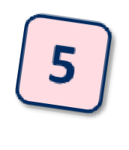      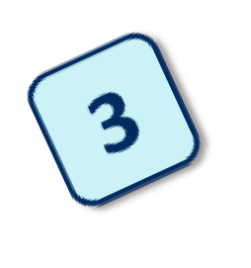    Begin to link numerals to quantities.
Add 1 more  Through stories, songs and rhymes. |   How many do I have now?

©White Rose Education 2024 6

Addition

Reception | - Have a deep understanding of numbers to 10, including the composition of each number.  - Subitise (recognise quantities without counting) up to 5  - Automatically recall (without reference to rhymes, counting or other aids) number bonds up to 5 and some number bonds to 10, including double facts.
Progression of skills | Key representations
Conceptually subitise to 5  Notice the parts that make up the whole. |   What do you see? How do you see it?  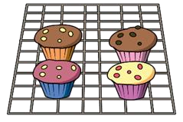
1 more  Continue to link to stories, songs and rhymes. | 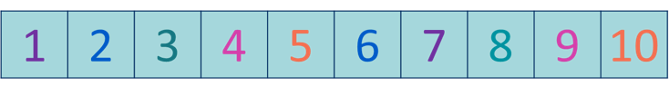    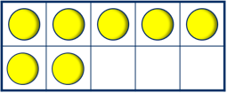    1 more than … is …  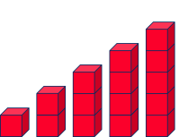
Notice the composition of numbers within 10  Link to stories, songs and rhymes. | How many…? How many…?            How many altogether?  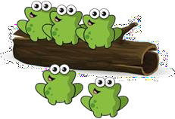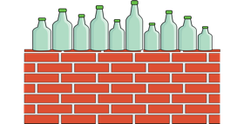 | How many ways can you make…?    
©White Rose Education 2024 7

Addition

Progression of skills | Key representations
Combine 2 groups  2 groups are combined to find the total. | 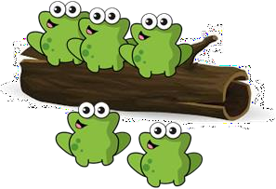  There are …. There are ….  There are …. altogether.  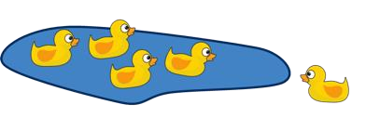 | …. and …. make ….  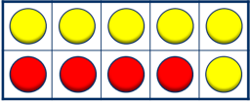
Add more  A quantity is increased. | First… Then…. Now….    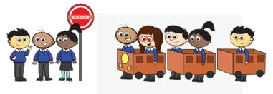 | I have ….    I add …. more.    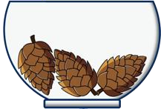    Now I have….

©White Rose Education 2024 8

Addition

Year 1 | - Read, write and interpret mathematical statements involving addition (+) and equals (=) signs.  - Represent and use number bonds within 20  - Add 1-digit and 2-digit numbers to 20, including zero.  - Solve one-step problems that involve addition, using concrete objects and pictorial representations, and missing number problems such as 7 = + 2
Progression of skills | Key representations
Add together  (aggregation)  2 quantities are combined to find the total. | There are … There are …      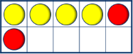  There are … altogether.  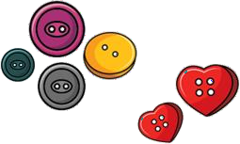 | … is a part.  … is a part.  … is the whole.  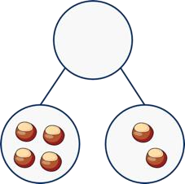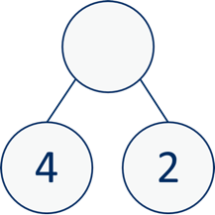 | ... plus … is equal to …  … is equal to …. + …  4 + 2 = 6  2 + 4 = 6  6 = 4 + 2  6 = 2 + 4
Add more  (augmentation)  A quantity is increased. |   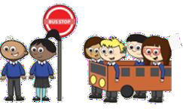  First… Then… Now…  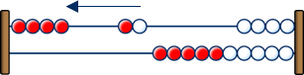 | I start at … I jump on … I land on …  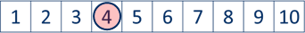  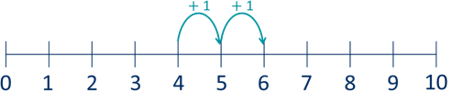 | … plus … is equal to  … is equal to … + …  4 + 2 = 6  2 + 4 = 6  6 = 4 + 2  6 = 2 + 4
©White Rose Education 2024 9

Addition

Progression of skills | Key representations
Bonds within 10  Include bonds for each number within 10  Encourage children to notice patterns. | … is made of … and …  … and … make …    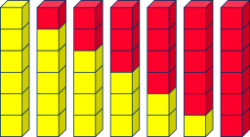 | … can be partitioned into …  and …  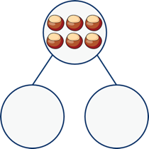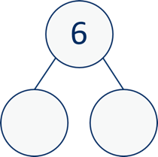 | … plus … is equal to …  6 + 0 = 6  5 + 1 = 6  4 + 2 = 6  3 + 3 = 6  2 + 4 = 6  1 + 5 = 6  0 + 6 = 6
Related facts within 20  Make links to known facts. | I know that … and ... = … so … and … = ...  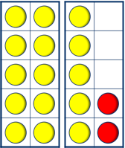 | … more than … is …  so … more than … is …  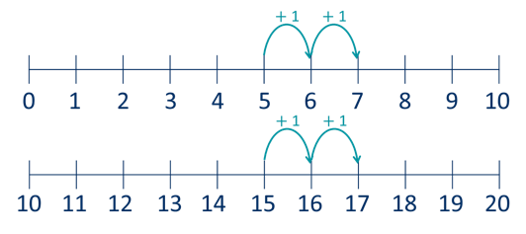 | What patterns do you notice?  5 + 2 = 7  15 + 2 = 17  7 = 5 + 2  17 = 15 + 2
Missing numbers  Make links to known facts. | How many more do you need to make …?    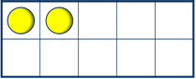 | 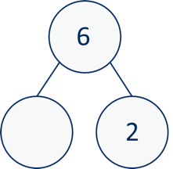  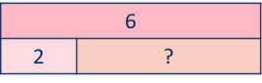  If … is the whole and … is a part, the other part must be… | … plus … is equal to …  2 + = 6  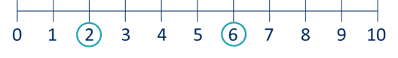  6 = 2 +

©White Rose Education 2024 10

Addition

Year 2 | - Recall and use addition facts to 20 fluently, and derive and use related facts up to 100  - Add numbers using concrete objects, pictorial representations, and mentally,  including:  - a two-digit number and 1s  - a two-digit number and 10s  - 2 two-digit numbers  - adding 3 one-digit numbers  - Recognise and use the inverse relationship between addition and subtraction and use this to check calculations and solve missing number problems.
Progression of skills | Key representations
Add ones to any number  (related facts)  Make links to known facts. | I know that … and ... = … so … and … = ...  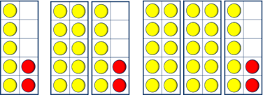 | … more than … is …  so … more than … is …  + 1 + 1  0 1 2 3 4 5 6 7 8 9 10  + 1 + 1  20 21 22 23 24 25 26 27 28 29 30 |  |  |  |  | What do you notice? Can you continue the pattern?  5 + 2 = 7  15 + 2 = 17  25 + 2 = 27…
Add three 1-digit numbers  Prompt children to understand that addition can be done in any order and to make links to known facts. | 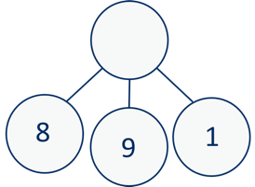  … and … are a bond to 10 10 + … = …  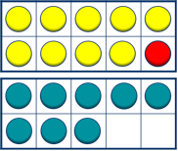  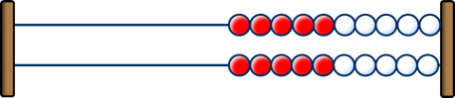 | Double … + … = … |  |  |  |  | What do you notice? Which addition is the easiest to calculate?  8 + 9 + 1 =  8 + 1 + 9 =  9 + 1 + 8 =
 |  |  | ?
 |  |  | 4 | 3 | 3
 |  | 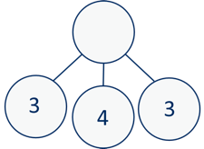
©White Rose Education 2024 11

Addition

Progression of skills | Key representations
Add across a 10  Partition the number being added to make a full ten. | … can be partitioned into … and …  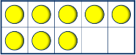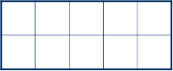  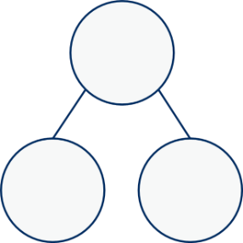  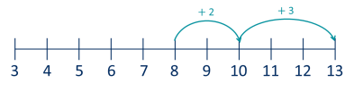  8 + 5  2 3 |  | I add … to get to … then I add … 8 + 5 = 13  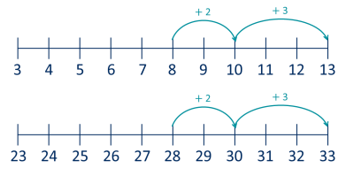  28 + 5 = 33  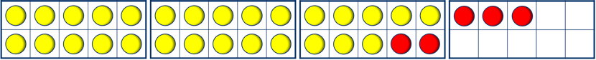  28 + 5  2 3
Add multiples of 10  Make links to known facts within ten. | 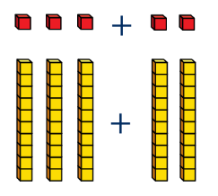  … ones + … ones = … ones so … tens + … tens = … tens  3 + 2 = 5  30 + 20 = 50 | 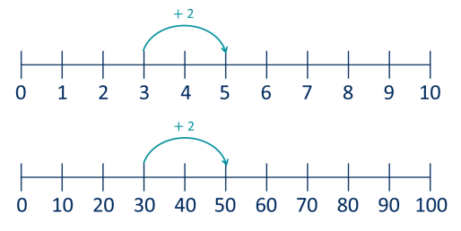  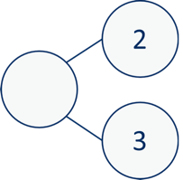  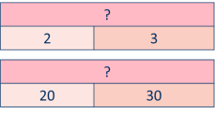  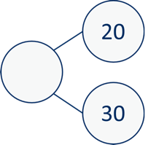  What is the same? What is different?
Add 10s to any number  Make links to known facts. | … tens + … tens = … tens  … tens and … ones = …  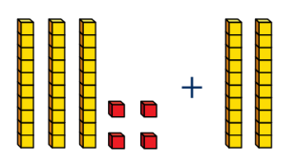 | To add … I need to add 10  … times.  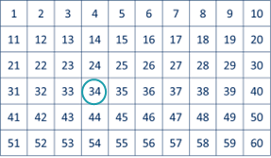 |  | I know that … and ... = … so … and … = ...  30 + 20 = 50  34 + 20 = 54
©White Rose Education 2024 12

Addition

Progression of skills | Key representations
Add 2-digit numbers  (not across a ten)  Lining up ones and tens in columns will support with later written methods. | … ones + … ones = … ones 3 ones + 1 one = 4 ones  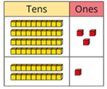  … tens + … tens = … tens 4 tens + 2 tens = 6 tens  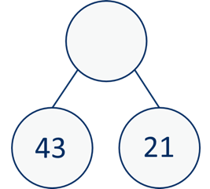  6 tens + 4 ones = 64  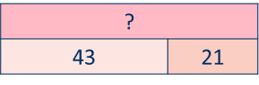
Add 2-digit numbers  (across a ten)  Begin to exchange 10 ones for 1 ten. | There are …. ones, so I do/do not need to make an exchange.  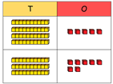  … ones = … ten and … ones
 |  |  | ?
 |  |  | 45 | 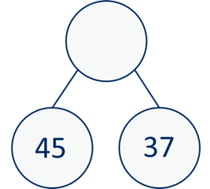  37
5 ones + 7 ones = 12 ones
12 ones = 1 ten and 2 ones
4 tens + 3 tens + 1 ten = 8 tens
8 tens and 2 ones = 82
Missing numbers  Solve missing number problems and use the inverse to check. | How many more do you  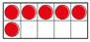  need to make …?  6 + = 10  10 − = 6 | 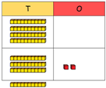  If … is a whole and … is a part, then … is the other part.  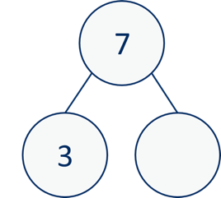  + 3 = 7  7 − 3 = |  | … can be partitioned into …  and …  10 + 8 = 12 +  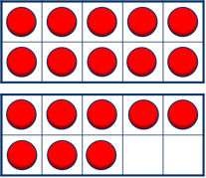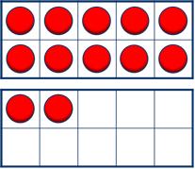
©White Rose Education 2024 13

Addition

Year 3 | - Add numbers mentally, including: a three-digit number and ones, a three-digit number and tens, a three-digit number and hundreds.  - Add numbers with up to three digits, using formal written methods of columnar  addition.  - Add fractions with the same denominator within 1 whole.  - Calculate the time taken by particular events or tasks.
Progression of skills | Key representations
Add 1s, 10s or 100s to a 3-digit number  Emphasis on mental strategies including number bonds and related facts.  Prompt children to notice which digit changes. | The ones/tens/hundreds column will increase by …  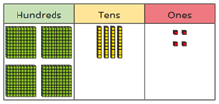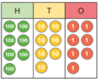  444 + 5 = 777 + 2 =  444 + 50 = 777 + 20 =  444 + 500 = 777 + 200 = | What patterns do you notice?  235 + 3 =  235 + 30 =  235 + 300 =
 |  | 111 +  604 + 20 = 111 +  604 + 50 =  604 + 90 = 111 + |  | = 118  = 181  = 811
Add two numbers  (no exchange)  Mental strategies and introduction of formal written method. | 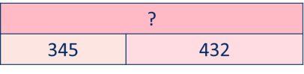  ... ones + … ones = … ones  ... tens + … tens = … tens  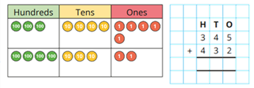  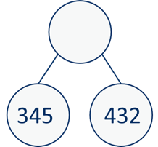  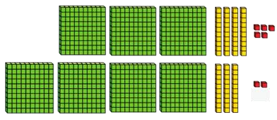  ... hundreds + … hundreds = … hundreds

©White Rose Education 2024 14

Addition

Progression of skills | Key representations
Add two numbers across a  10 or 100  Formal written method involving up to 2 exchanges including 3-digit plus 2-digit numbers. | There are … ones, so I do/do not need to make an exchange.  There are … tens, so I do/do not need to make an exchange.  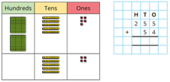  … ones = … ten and … ones.  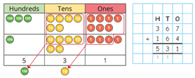  … tens = … hundred and … tens.  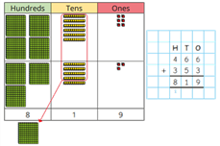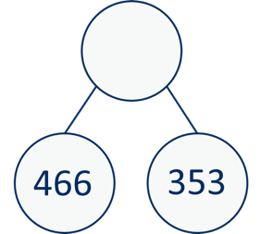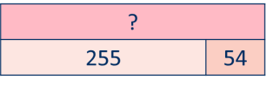
Complements to 100  Pairs of numbers which total 100 | 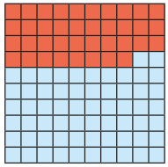  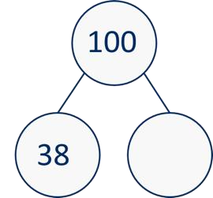  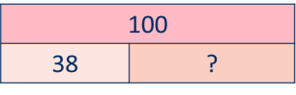  … plus … is equal to 100 | 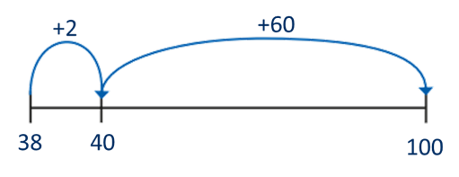  I add … to get to the next 10, then ... to get to 100  38 + 62 = 100  62 + 38 = 100  100 = 38 + 62  100 = 62 + 38

©White Rose Education 2024 15

Addition

Progression of skills | Key representations
Add fractions with the same denominator within 1 whole  Make links with known facts. | When adding fractions with the same denominator, I only add the numerator.  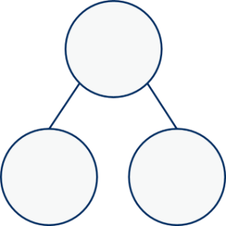  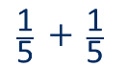  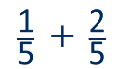  … fifths + … fifths = … fifths
Calculate the duration of events  Find durations of time between a given start and end point. Children will need to calculate complements to 60 | 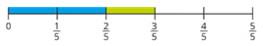  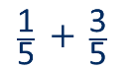  From … to … o’clock is … minutes. From … o’clock to … is … minutes. The total time taken is … minutes.  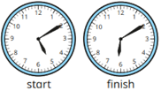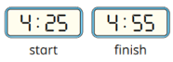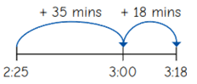

©White Rose Education 2024 16

Addition

Year 4 | - Add numbers with up to 4 digits using a formal written method.  - Solve simple measure and money problems involving fractions and decimals to 2  decimal places.  - Add fractions with the same denominator.
Progression of skills | Key representations
Add 1s, 10s and 100s to a 4-digit number  Emphasis on mental strategies including number bonds and related facts.  Prompt children to notice  which digit changes. | The ones/tens/hundreds/thousands column will increase by …  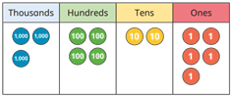  3,425 + 3 = 3,425 + 300 =  3,425 + 30 = 3,425 + 3,000 = | What patterns do you notice? 2,350 + 3 =  2,350 + 30 =  2,350 + 300 =  2,350 + 3,000 =
 |  | 6,040 + 200 = 2,211 +  6,040 + 500 = 2,211 +  6,040 + 900 =  2,211 + |  | = 2,251  = 2,215  = 2,511
Add up to two 4-digit numbers  Formal written method with up to 3 exchanges.  Encourage children to estimate and use inverse operations to check answers to calculations. | 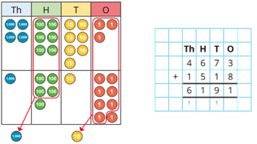  There are … ones/tens/hundreds so I do/do not need to make an exchange.  I can exchange 10 … for 1 …
©White Rose Education 2024 17

Addition

Progression of skills | Key representations
Add decimal numbers in the context of money | … pence + … pence = … pence  … pounds + … pounds = … pounds | 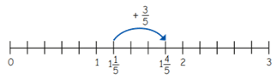    £3.25 can be partitioned into £3 + 20p + 5p
Emphasis on partitioning and use of number lines rather than formal written calculations. |   45p + 25p = 70p  £2 + £3 = £5  £5 + 70p = £5.70 | 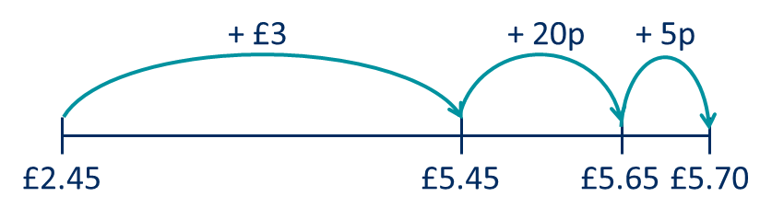
Add fractions and mixed | When adding fractions with the same denominator, I only add the numerator.
numbers with the same |   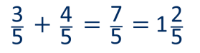  … fifths + … fifths = … fifths
denominator beyond 1
whole

©White Rose Education 2024 18

Addition

Year 5 | - Add whole numbers with more than 4 digits, including using formal written methods.  - Add numbers mentally with increasingly large numbers.  - Add decimals, including a mix of whole numbers and decimals, decimals with different numbers of decimal places, and complements of 1  - Add fractions with the same denominator, and denominators that are multiples of the  same number.
Progression of skills | Key representations
Add using mental strategies  Add 1s, 10s, 100s, etc. to any number.  Use number bonds and related facts. | 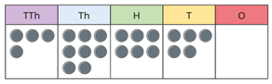  48,650 + 300 =  48,650 + 30,000 =  48,650 + 30 = | To add …, I can add … then subtract …
 |  |  | ?
 |  |  | 6,458 | 99
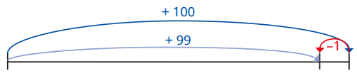
6,458 6,557 6,558
Add whole numbers with more than 4 digits  Encourage children to estimate and use inverse operations to check answers to calculations. | 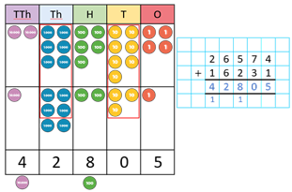  I can exchange 10 … for 1 …  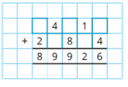
©White Rose Education 2024 19

Addition

Progression of skills | Key representations
Add decimals with up to 2 | I do/do not need to make an exchange because …
decimal places  Progress from the same number of decimal places to a different number of decimal places, and from no exchange to exchange. | 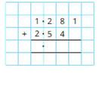  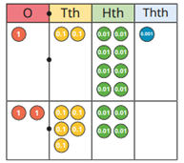  I can exchange 10 … for 1 …  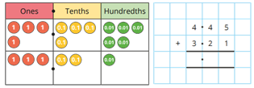
Complements to 1 | 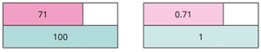  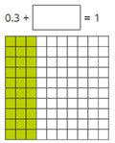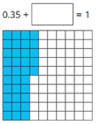  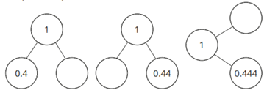  4 + 6 = 10  44 + 56 = 100  444 + 556 = 1,000 | 0.4 + 0.6 = 1  0.44 + 0.56 =  0.444 + 0.556 | 1  = | 1
Pairs of numbers with up to
3 decimal places which total
1
Encourage children to make
links with bonds to 10 and
complements to 100 and
1,000

©White Rose Education 2024 20

Addition

Progression of skills | Key representations
Add fractions with denominators that are a multiple of one another  Encourage children to convert fractions to the same denominator before adding.  Progress from adding fractions within 1 whole to adding fractions beyond 1 whole. | 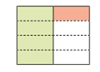  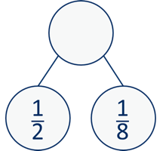  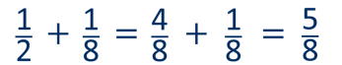  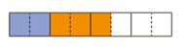  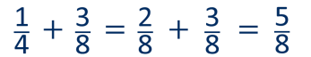  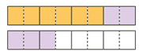  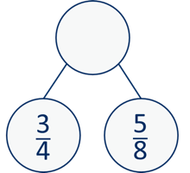  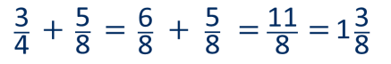  The denominator has been multiplied by … , so the numerator needs to be multiplied by… for the fractions to be equivalent.

©White Rose Education 2024 21

Addition
Year 6 | - Add larger numbers, using the formal written method of columnar addition.  - Use their knowledge of the order of operations to carry out calculations involving the  4 operations.  - Calculate intervals across zero.  - Add fractions with different denominators and mixed numbers, using the concept of  equivalent fractions.
Progression of skills | Key representations
Add integers up to 10 million
Encourage children to estimate and use inverse operations to check answers to calculations.
 |  |  |  | 3 | 4 | 6 | 2 | 2 | 1
 |  |  | + | 1 | 8 | 4 | 3 | 2 | 1
 |  |  |  | 5 | 3 | 0 | 5 | 4 | 2
 |  |  |  | 1 | 1
Add decimals with up to 3 decimal places  Progress to numbers with digits in different place value columns.  Encourage children to check that they have lined up the columns correctly. | I do/do not need to make an exchange because ...
 |  |  |  |  |  |  |  |  |  |  |  |  |  | 1 | 5 | . 0 | 2 | 7
 |  |  |  |  |  |  |  |  |  |  |  |  | + |  | 9 | 5 | 8
 |  |  |  |  |  |  |  |  |  |  |  |  |  | 2 | 4 | 6 | 0 | 7
 |  |  |  |  |  |  |  |  |  |  |  |  |  | 1 |  | 1

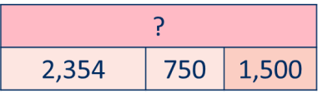
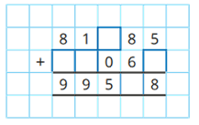

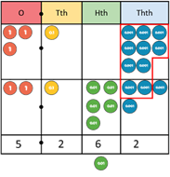
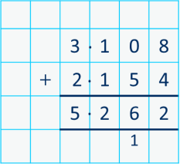
.
.

©White Rose Education 2024 22

Addition

Progression of skills | Key representations
Order of operations  Calculations in brackets should be done first.  Multiplication and division should be performed before addition and subtraction.  *When no brackets are shown and the operations have the same priority, work left to right. | 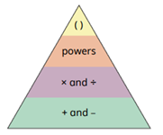  … has greater priority than …, so the first part of the calculation I need to do is …    (3 + 4) × 2 = 14 3 + 4 × 2 = 11    3 × 4 + 2 = 14
Negative numbers  Children add to negative | … plus … is equal to … |  | −3 + 5 = 2 |   −5 −4 −3 −2 −1 0 1 2 3 4 5
numbers and carry out  calculations which cross 0 |   −5 −4 −3 −2 −1 0 | 1 | 2 3 4 5 | The difference between – 5 and −1 is 4
numbers and carry out  calculations which cross 0 | + 11 | + 5 | −11 + 16 = 5 | 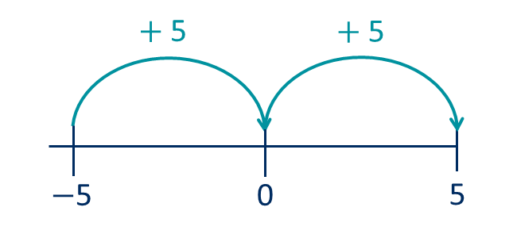
 | −11 0 |  | 5 | The difference between – 5 and 5 is 10

©White Rose Education 2024 23

Addition

Progression of skills | Key representations
Add fractions  Convert fractions to the same denominator before adding. Progress from fractions where one denominator is a multiple of the other, to any fractions and then to mixed numbers. | The denominator has been multiplied by … , so the numerator needs to be  multiplied by …  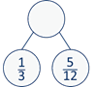  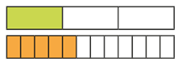 | 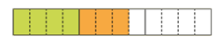  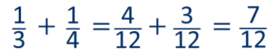  The lowest common multiple of … and … is …  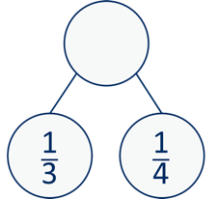 | …is made up of … wholes and …  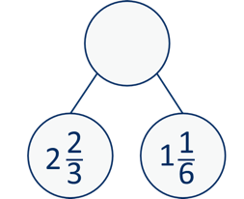  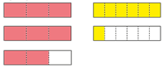

©White Rose Education 2024 24

Progression of skills - Subtraction

Year group | Skill
Reception | - Conceptually subitise to 5  - 1 less  - Notice the composition of numbers within 10  - Partition  - Take away
Year 1 | - Find a part  - Take away  - Bonds within 10  - Related facts within 20  - Missing numbers

©White Rose Education 2024 25

Progression of skills - Subtraction

Year group | Skill
Year 2 | - Subtract 1s from any number (related facts)  - Subtract across a 10  - Subtract multiples of 10  - Subtract 10s from any number  - Subtract two 2-digit numbers (not across a ten)  - Subtract two 2-digit numbers (across a ten)  - Missing numbers
Year 3 | - Subtract 1s, 10s and 100s from a 3-digit number  - Subtract two numbers (no exchange)  - Subtract two numbers across a 10 or 100  - Complements to 100  - Subtract fractions with the same denominator within 1 whole

©White Rose Education 2024 26

Progression of skills - Subtraction

Year group | Skill
Year 4 | - Subtract 1s, 10s, 100s and 1,000s from a 4-digit number  - Subtract up to two 4-digit numbers  - Subtract decimal numbers in the context of money  - Subtract fractions and mixed numbers with the same denominator
Year 5 | - Subtract whole numbers with more than 4 digits  - Subtract using mental strategies  - Subtract decimals with up to 2 decimal places  - Complements to 1  - Subtract fractions with denominators that are a multiple of one another
Year 6 | - Subtract integers up to 10 million  - Subtract decimals with up to 3 decimal places  - Order of operations  - Negative numbers  - Subtract fractions
©White Rose Education 2024 27

Subtraction

Progression of skills | Key representations
Subitise to 3  Instantly see how many. | How many do you see?
Count how many  Begin to count objects using 1-1 correspondence. | How many are there?  3 | Count out … from a larger group.        E.g. Collect a cup for everyone at the table.
Make numbers to 5  Start by showing 1, 2 and 3 using fingers. | Show me… | Begin to link numerals to quantities.
Take 1 away  Through stories, songs and rhymes. |         How many do we have now?  

©White Rose Education 2024 28

Subtraction

Reception | - Have a deep understanding of number to 10, including the composition of each number.  - Subitise (recognise quantities without counting) up to 5  - Automatically recall (without reference to rhymes, counting or other aids) number bonds up to 5 (and some subtraction facts) and some number bonds to 10, including double facts.
Progression of skills | Key representations
Conceptually subitise to 5  Notice the parts that make up the whole. | What do you see? How do you see it?  
1 less  Continue to link to stories, songs and rhymes. |   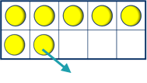  1 less than … is …  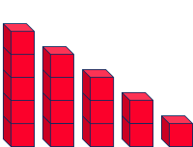
Notice the composition of numbers within 10  Link to stories, songs and rhymes. | 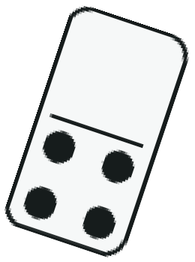  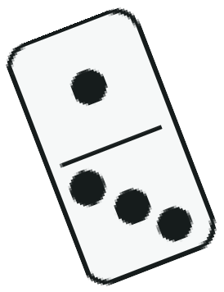  How many…? How many…?  How many altogether?  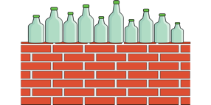 | How many ways can you make…?
©White Rose Education 2024 29

Subtraction

Progression of skills | Key representations
Partition  Using objects, explore different ways to partition a number into 2 or more parts. | There are … altogether.  I can see … here and … there. | … and … make …
Take away  A quantity is reduced. |     First… Then… Now… | I have …  I take … away  Now I have …

©White Rose Education 2024 30

Subtraction

Year 1 | - Read, write and interpret mathematical statements invol equals (=) signs.  - Represent and use number bonds and related subtraction  - Subtract one-digit and two-digit numbers to 20, including  - Solve one-step problems that involve subtraction, using c representations, and missing number problems such as 7 |  |  |  |  |  |  |  |  |  |  |  |  |  |  |  |  |  |  |  | ving subtraction (–) and  facts within 20 zero.  oncrete objects and pictorial  = – 9
Progression of skills | Key representations
Find a part  Link to number bonds and known facts. E.g. 2 + 4 = 6 so if 6 is the whole and 4 is a part, the other part must be 2 | There are … in total.  … are …      How many are not …? | … is the whole.  … is a part.  … is a part.  6 |  |  |  |  |  |  |  |  |  | 6 |  |  |  | 4 |  |  |  |  | … subtract … is equal to …  … is equal to … − …  6 − 2 = 4  6 − 4 = 2  4 = 6 − 2  2 = 6 − 4
Take away  A quantity is decreased. |   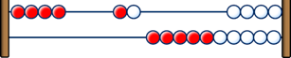  First… Then… Now… | I start at …  I jump back … I land on … |  |  |  |  |  |  |  |  |  |  |  |  |  |  |  |  |  |  | … minus … is equal to …  … is equal to … − …  6 − 2 = 4  6 − 4 = 2  4 = 6 − 2  2 = 6 − 4
Take away  A quantity is decreased. |  |  | 1 | 2 | 3 | 4 | 5 |   6 |  |  | 7 |  | 8 |  | 9 |  |  | 10
Take away  A quantity is decreased. |  | − 1  0 1 2 3 4 5 |  |  |  |  |  |  | −1 | 6 |  | 7 |  | 8 |  |  | 9 |  | 10
©White Rose Education 2024 31

Subtraction

Progression of skills | Key representations
Bonds within 10  Focus on subtraction facts.  Encourage children to notice patterns. | … is made of … and …  … and … make … | … can be partitioned into …  and … | … minus … is equal to …  6 − 0 = 6  6 − 1 = 5  6 − 2 = 4  6 − 3 = 3  6 − 4 = 2  6 − 5 = 1  6 − 6 = 0
Related facts within 20  Make links to known facts. | 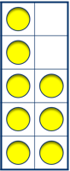      I know that … minus ... = … so … minus … = ... | … less than … is … so … less than … is …  −1 − 1 − 1  0 1 2 3 4 5 6 7 8 9 10  −1 − 1 − 1  10 11 12 13 14 15 16 17 18 19 20 | What patterns do you notice?  8 − 3 = 5  18 − 3 = 15  5 = 8 − 3  15 = 18 − 3
Missing numbers  Make links to known facts. | How many do you need to subtract to make …?  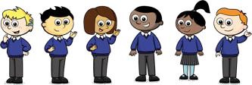  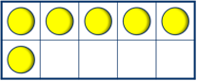 | If … is the whole and … is a part, the other part must be… | … minus … is equal to …  6 − = 2  2 = 6 −

©White Rose Education 2024 32

Subtraction

- Recall and use subtraction facts to 20 fluently, and derive and use related facts up to 100
- Subtract numbers using concrete objects, pictorial representations, and mentally,
including:
  - a two-digit number and 1s
  - a two-digit number and 10s
  - 2 two-digit numbers
- Recognise and use the inverse relationship between addition and subtraction and use this to check calculations and solve missing number problems.
Progression of skills | Key representations
Subtract ones from any | I know that … minus ... = … | … less than … is … |  |  |  |  |  |  | What do you notice? Can you continue the pattern?  8 − 3 = 5  18 − 3 = 15  28 − 3 = 25…
number | so … minus … = ... | so … less than … is …
(related facts)  Make links to known facts. | 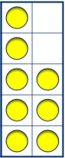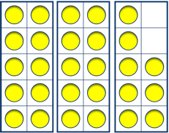 | 0 1 2  20 21 22 | 3  23 |  | 4  24 | −1 − 1 − 1  5 6 7 8  −1 − 1 − 1  25 26 27 28 | 9  29 | 10  30
Subtract across a 10 | … can be partitioned into … and …  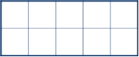  − 2 − 3  13 − 5  3 4 5 6 7 8 9 10 11 12 13  3 2 |  |  | Make links with related facts.
Partition the number being |  |  |  | 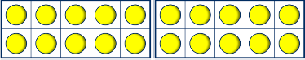
subtracted to bridge |  |  |  |  |  |  |  |  |  |  |  |  |  |  | − 2 |  | − 3
through a ten. |  |  |  | 33 − 5
 |  |  |  |  |  |  |  |  | 3 | 4 | 5 | 6 | 7 | 8 | 9 | 10 | 11 12 | 13
 |  |  |  |  |  |  |  |  |  |  |  |  |  |  | − 2 |  | − 3
 |  |  |  | 3 2
 |  |  |  |  |  |  |  |  | 23 | 24 | 25 | 26 | 27 | 28 | 29 | 30 | 31 32 | 33
©White Rose Education 2024 33

Subtraction

Progression of skills | Key representations
Subtract multiples of 10 | 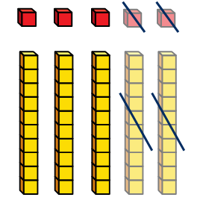  … ones − … ones = … ones so … tens − … tens = … tens  5 − 2 = 3  50 − 20 = 30 | 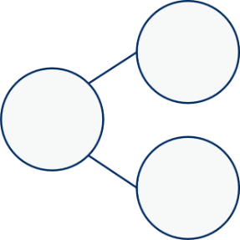  What is the same? What is different?  − 2 |  |  |  |  |  | 5 | 2 | 50 | 20
Make links to known facts
within ten.
 |  | 0 1 2 3 4 5 6 | 7 | 8 | 9 |  | 10 |  | 5
 |  |  |  |  |  |  |  |  | 2 | ?
 |  | − 2 |  |  |  |  |  |  | 2
 |  |  |  |  |  |  |  |  | 50
 |  | 0 10 20 30 40 50 60 | 70 | 80 | 90 |  | 100 |  | 20 | ?
Subtract 10s from any number  Make links to known facts. | … tens − … tens = … tens  … tens and … ones = …  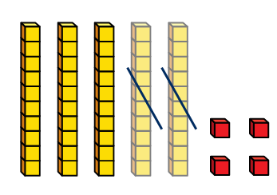 | 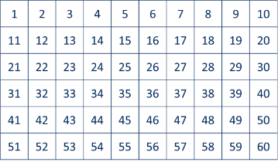    To subtract … I need to subtract 10 … times. |  |  |  | I know that … minus ... = … so … minus … = ...  50 − 20 = 30  54 − 20 = 34

©White Rose Education 2024 34

Subtraction

Progression of skills | Key representations
Subtract two 2-digit  numbers  (not across a ten) | … ones − … ones = … ones  … tens − … tens = … tens  43 |  |  |  |  |  |  | 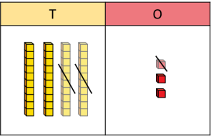  3 ones − 1 one = 2 ones
Subtract two 2-digit  numbers  (not across a ten) | 21 |  |  | 43 |  |  |  |  | 4 tens − 2 tens = 2 tens  2 tens and 2 ones = 22
Subtract two 2-digit  numbers  (not across a ten) |  |  |  | 21 |  |  | ?
Subtract two 2-digit | I need to make an exchange because I do not have enough ones to subtract … ones.
numbers
numbers |  | 43 |  |  |  | T |  | O |  |  | T | O |  |  | T | O
(across a ten)  Begin to exchange 1 ten for 10 ones. |  | 25 | ? |  |  | 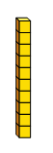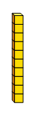 |  |  |  |  |  |  |  |  | 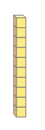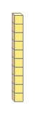 | 
(across a ten)  Begin to exchange 1 ten for 10 ones. |  | 43
 |  | 3 ones − 5 ones |  |  |  |  |  |  |  |  |  |  | 13 ones − 5 ones = 8 ones
 | 25 |  |  |  |  | (I need to exchange 1 ten for 10 ones) |  |  |  |  |  |  |  | 3 tens − 2 tens = 1 ten
 | 1 ten and 8 ones = 18
Missing numbers  Solve missing number problems and use the inverse to check. | How many do you need to subtract to make …?  10 − = 6  6 + = 10 |  |  |  |  |  |  | If … is a whole and … is a part, then … is the other part.  7 − 3 =  + 3 = 7 |  |  |  |  | … can be partitioned into … and …  18 − = 12 + 2
©White Rose Education 2024 35

Subtraction

... ones − … ones = … ones
Year 3 | - Subtract numbers mentally, including: a three-digit number and ones, a three-digit number and tens, a three-digit number and hundreds.  - Subtract numbers with up to three digits, using formal written methods.  - Subtract fractions with the same denominator within 1 whole.
Progression of skills | Key representations
Subtract 1s, 10s and 100s from a 3-digit number  Emphasis on mental strategies including number bonds and related facts.  Prompt children to notice  which digit changes. | The ones/tens/hundreds column will decrease by …  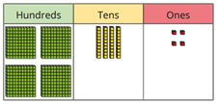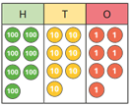  444 − 2 = 777 − 4 =  444 − 20 = 777 − 40 =  444 − 200 = 777 − 400 = | What patterns do you notice?  235 − 3 =  235 − 30 =  235 − 300 =
 |  | 118 −  624 − 20 = 181 −  654 − 50 =  694 − 90 = 811 − |  |  |  | = 111  = 111  = 111
Subtract two numbers (no exchange)
Mental strategies and introduction of formal written method.
 | ... tens − … tens = … tens |  | 769
 |  |  | 147 | ?
... hundreds − … hundreds = … hundreds

345

143

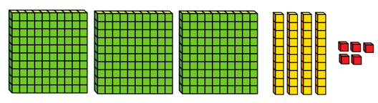
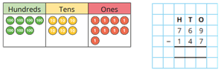

©White Rose Education 2024 36

Subtraction

Progression of skills | Key representations
Subtract two numbers  across a 10 or 100  Formal written method involving up to 2 exchanges including 3-digit subtract  2-digit numbers. | 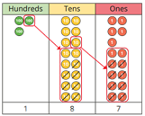  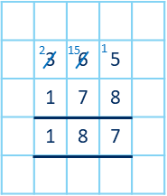  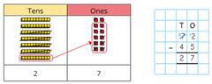  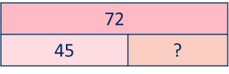  I need to subtract … ones. I do/do not need to make an exchange. I need to subtract ... tens. I do/do not need to make an exchange. I can exchange 1 … for 10 …  452  43  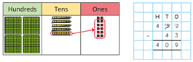
Complements to 100  Focus on subtraction facts.  Encourage children to notice patterns. | 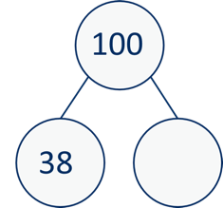  100 minus … is equal to … | I subtract … tens, then I subtract … ones.  100 − 38 = 62  100 − 62 = 38  62 = 100 − 38  − 8 − 30 38 = 100 − 62  62 70 100

©White Rose Education 2024 37

Subtraction

Progression of skills | Key representations
Subtract fractions with the same denominator within 1 whole  Make links with known facts. | When subtracting fractions with the same denominator, I only subtract the numerator.  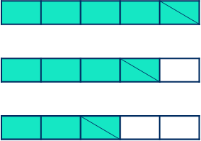  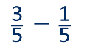  … fifths − … fifths = … fifths  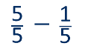  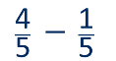

©White Rose Education 2024 38

Subtraction
Year 4 | - Subtract numbers with up to 4 digits using a formal written method.  - Solve simple measure and money problems involving fractions and decimals to 2  decimal places.  - Subtract fractions with the same denominator.
Progression of skills | Key representations
Subtract 1s, 10s, 100s and | The ones/tens/hundreds/thousands column will decrease by …  3,425 − 2 = 3,425 − 200 =  3,425 − 20 = 3,425 − 2,000 = | What patterns do you notice?
1,000s from a 4-digit  number |  | 4,356 − 3 =  4,356 − 30 =
Emphasis on mental |  | 4,356 − 300 =
strategies including number |  |  | 4,433 − |  | = 4,430
bonds and related facts. Prompt children to notice which digit changes. |  | 6,940 − 200 =  6,940 − 300 =  6,940 − 400 = | 4,433 −  4,433 − |  | = 4,033  = 4,403
Subtract up to two 4-digit numbers  Formal written method with up to 3 exchanges.  Encourage children to estimate and use inverse operations to check answers to calculations. | I need to subtract… ones/tens/hundreds. I do/do not need to make an exchange. I can exchange 1… for 10…

4,356 − 3,000 =

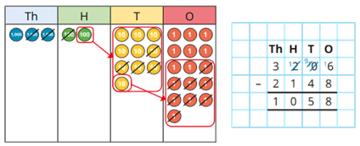
©White Rose Education 2024 39

Subtraction

Progression of skills | Key representations
Subtract decimal numbers in the context of money | I can partition £… into £… and 100p  £… − £… = £… 100p − …p = …p | £3.26 can be partitioned into £3 + 20p + 6p
Emphasis here is on  partitioning and use of number lines rather than formal written calculations. | £5 − £3.26 £5  £4 − £3 = £1  100p − 26p = 74p £4 100p  £5 - £3.26 = £1.74 | − 6p − 20p − £3
 |  | 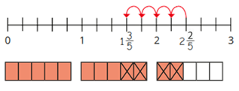  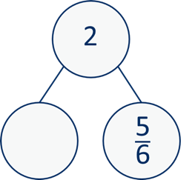  £1.74 £1.80 |  |  | £2 |  |  |  |  |  | £5
Subtract fractions and mixed numbers with the same denominator | When subtracting fractions with the same denominator,
 | I only subtract the numerator.
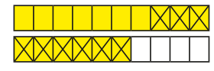
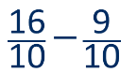
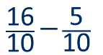
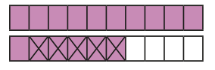
… tenths − … tenths = … tenths
Include subtracting fractions
from wholes.

©White Rose Education 2024 40

Subtraction

Year 5 | - Subtract whole numbers with more than 4 digits.  - Subtract numbers mentally with increasingly large numbers.  - Subtract decimals, including a mix of whole numbers and decimals, decimals with different numbers of decimal places, and complements of 1  - Subtract fractions with the same denominator, and denominators that are multiples of  the same number.
Progression of skills | Key representations
Subtract whole numbers with more than 4 digits  Encourage children to estimate and use inverse operations to check answers to calculations. | I can exchange 1 … for 10 …  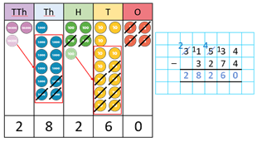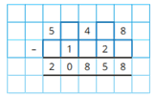
Subtract using mental | 48,650 − 300 =  48,650 − 30,000 =  48,650 − 30 = | To subtract …, I can subtract … then add …
strategies
Subtract 1s, 10s, 100s etc |  |  | 6,558 |  | − 100
Subtract 1s, 10s, 100s etc |  |  | 99 | ?
from any number. |  |  |  |  |  | − 99
Use number bonds and |  |  |  | + 1
related facts. |  |  |  | 6,458 6,459 |  |  | 6,558
©White Rose Education 2024 41

Subtraction

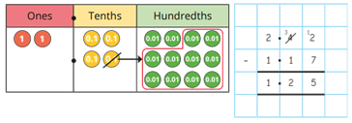
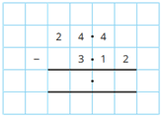
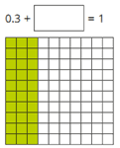
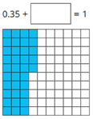

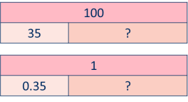
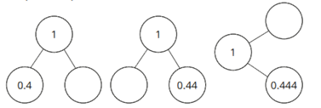
100 − 44 = 56 1 − 0.44 = 0.56
Progression of skills | Key representations
Subtract decimals with up to 2 decimal places
Progress from the same number of decimal places to a different number of decimal places and from no exchange to exchange.
 |  |  |  |  |  |  |  | 24.4
 |  |  |  |  |  |  |  | 3.12 | ?
24.4
3.12
Complements to 1  Encourage children to make links with bonds to 10 and complements to 100 and 1,000 when finding a missing part or subtracting from 1 |  | 0.3 + |  | = 1 | 0.35 + | = 1
 |  | 10 |  |  |  |  | 10 − 4 = 6 |  |  | 1 − 0.4 = 0.6
 |  | 3 | ?
 |  | 1
 |  | 0.3 | ?

©White Rose Education 2024 42

Subtraction

Progression of skills | Key representations
Subtract fractions with denominators that are a multiple of one another  Convert fractions to the same denominator before subtracting. Progress from subtracting fractions within 1 whole to subtracting from a mixed number. | 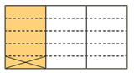  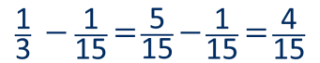  The denominator has been multiplied by … , so the numerator needs to be multiplied by… for the fractions to be equivalent.  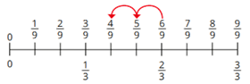  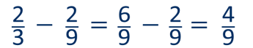  2  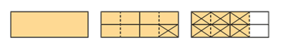

©White Rose Education 2024 43

Subtraction
Year 6 | - Subtract larger numbers, using the formal written methods of columnar subtraction.  - Use their knowledge of the order of operations to carry out calculations involving the  4 operations.  - Calculate intervals across zero.  - Subtract fractions with different denominators and mixed numbers, using the concept  of equivalent fractions.
Progression of skills | Key representations
Subtract integers up to 10 million
Encourage children to estimate and use inverse operations to check answers to calculations.
 |  |  |  |  |  | 23 |  | 14 |  | 56 | 12 | 2 | 1
 |  |  |  | − |  | 1 |  | 8 |  | 4 | 3 | 2 | 1
 |  |  |  |  |  | 1 |  | 6 |  | 1 | 9 | 0 | 0
 |  |  |  |  |  |  |  |  |  |  |  |  |  |  |  | 4,604
 |  |  |  |  |  |  |  |  |  |  |  |  |  |  |  | 2,354 | 750 | ?
Subtract decimals with up to 3 decimal places  Progress from the same number of decimal and whole number places to a different number of decimal and whole number places. | I do/do not need to make an exchange because ...
 |  |  |  |  |  |  |  |  | 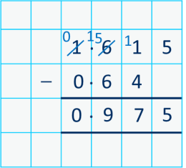
 |  |  |  |  | 6 |  | .67 | 13
 |  |  | − |  | 1 |  | 3 | 4
 |  |  |  |  | 5 |  | 3 | 9

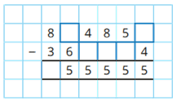

.
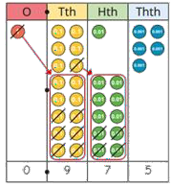
.
©White Rose Education 2024 44

Subtraction

Progression of skills | Key representations
Order of operations  Children learn the order of priority for operations in a calculation. Calculations in brackets should be done first. Multiplication and division should be performed before addition and subtraction. | 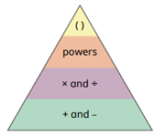  ... has greater priority than … , so the first part of the calculation I need to do is …    8 − 2 × 3 = 2 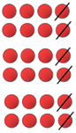 8 − 2² = 4    (8 − 2) × 3 = 18
Negative numbers | … minus … is equal to …
 |  |  |  | −1 − 4 = −5
Children subtract from |  |  |  |  | −5 −4 −3 −2 −1 0 1 2 3 4 5
positive and negative  numbers and calculate | −5 −4 −3 −2 −1 0 | 1 | 2 | 3 4 5 | The difference between – 5 and −1 is 4
intervals across 0 |  |  |  |  | − 5 − 5
 |  |  |  | 1 − 4 = −3
 |  |  |  |  | −5 0 5
 |   −5 −4 −3 −2 −1 0 | 1 | 2 | 3 4 5 | The difference between 5 and −5 is 10

©White Rose Education 2024 45

Subtraction

Progression of skills | Key representations
Subtract fractions  Convert fractions to the same denominator before subtracting. Progress from fractions where one denominator is a multiple of the other, to any fractions and then subtracting from a mixed number. | The denominator has been multiplied by … , so the numerator needs to be  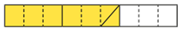  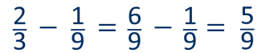  multiplied by… | The lowest common multiple of … and … is …  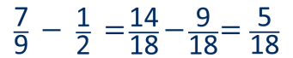 | … is made up of … wholes and …  2  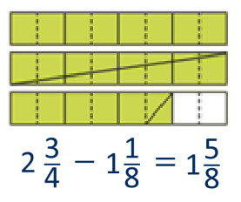  1

©White Rose Education 2024 46

Progression of skills - Multiplication

Year group | Skill
Reception | - Double to 10  - Make equal groups
Year 1 | - Count in 2s, 5s and 10s  - Add equal groups  - Make arrays  - Make doubles

©White Rose Education 2024 47

Progression of skills - Multiplication

Year group | Skill
Year 2 | - Link repeated addition and multiplication  - Use arrays  - Double  - The 2 times-table  - The 10 times-table  - The 5 times-table  - Missing numbers
Year 3 | - The 3 times-table  - The 4 times-table  - The 8 times-table  - Related facts  - Multiply a 2-digit number by a 1-digit number - no exchange  - Multiply a 2-digit number by a 1-digit number - with exchange  - Scaling  - Correspondence problems
©White Rose Education 2024 48

Progression of skills - Multiplication

Year group | Skill
Year 4 | - Times-table facts to 12 × 12  - Multiply by 1 and 0  - Multiply 3 numbers  - Factor pairs  - Multiply by 10 and 100  - Related facts  - Mental strategies  - Multiply a 2 or 3-digit number by a 1-digit number  - Scaling  - Correspondence problems

©White Rose Education 2024 49

Progression of skills - Multiplication

Year group | Skill
Year 5 | - Multiples and factors  - Square and cube numbers  - Multiply numbers up to 4 digits by a 1-digit number  - Multiply numbers up to 4 digits by a 2-digit number  - Multiply by 10, 100 and 1,000  - Mental strategies  - Multiply fractions by a whole number  - Multiply mixed numbers by a whole number  - Find the whole

©White Rose Education 2024 50

Progression of skills - Multiplication

Year group | Skill
Year 6 | - Multiply numbers up to 4 digits by a 2-digit number  - Multiply by 10, 100 and 1,000  - Order of operations  - Multiply decimals by integers  - Multiply fractions by fractions  - Find the whole  - Calculations involving ratio

©White Rose Education 2024 51

Multiplication

Reception | - Have a deep understanding of number to 10, including the composition of each number.  - Subitise (recognise quantities without counting) up to 5  - Automatically recall (without reference to rhymes, counting or other aids) number bonds up to 5 and some number bonds to 10, including double facts.  - Explore and represent patterns within numbers up to 10, including evens and odds, double facts and how quantities can be distributed equally.
Progression of skills | Key representations
Double to 10  Prompt children to notice that double means twice as many and to notice that there are two equal groups. | Double … is …          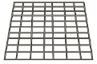            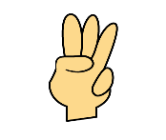  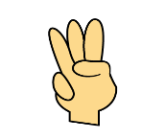      … is double …  
Make equal groups  Provide opportunities to make equal groups when tidying up or during snack time. Encourage children to check that each group has the same amount. |   There are … groups of … There are … altogether.  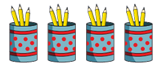

©White Rose Education 2024 52

Multiplication

Year 1 | - Count in multiples of twos, fives and tens.  - Solve one-step problems involving multiplication, using concrete objects, pictorial  representations and arrays with the support of the teacher.
Progression of skills | Key representations
Count in 2s, 5s and 10s  Begin by counting objects that naturally come in 2s, 5s and 10s, for example pairs of socks or fingers. | There are … equal groups of … There are … altogether.       | Continue to colour in ...s What do you notice?  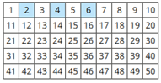 |  | Complete the number track/number line by counting in …s.  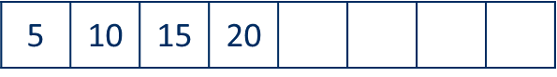  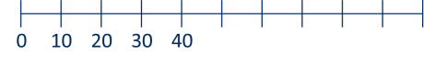
Add equal groups  (repeated addition)  Children should be able to write a repeated addition to represent equal groups and to draw pictures or use objects to represent a repeated addition. | There are … groups of …  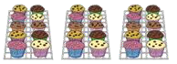  There are … altogether.  10 + 10 + 10 = 30   5 + 5 + 5 + 5 = 20 |  | What is the same? What is different?  2 + 2 + 2 =  5 + 5 + 5 =  10 + 10 + 10 =  Use objects or a drawing to represent the equal groups and find how many in total.
©White Rose Education 2024 53

Multiplication

Progression of skills | Key representations
Make arrays  Children use their knowledge of adding equal groups to arrange objects in columns and rows. | There are … rows of … There are … altogether.  There are … columns of … There are … altogether.  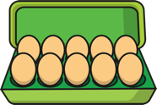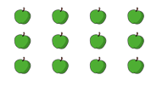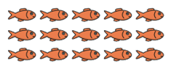
Make doubles  Children understand that doubles are two equal groups. Children may begin to explore doubles beyond 20 using base 10 | Double … is …  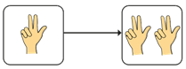  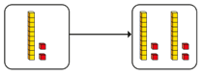      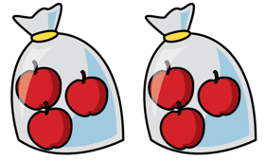  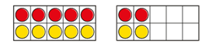  … + … = …

©White Rose Education 2024 54

Multiplication

Year 2 | - Recall and use multiplication facts for the 2, 5 and 10 multiplication tables.  - Calculate mathematical statements for multiplication within the multiplication tables  and write them using the multiplication (×) and equals (=) signs.  - Show that multiplication of two numbers can be done in any order (commutative).
Progression of skills | Key representations
Link repeated addition and multiplication  Encourage children to make the link between repeated addition and multiplication. | There are … equal groups with … in each group.
 | There are … altogether. |  |  |  | 6 |  |  |  | 3 + 3 = 6  2 × 3 = 6
 |  |  |  |  | 3 |  | 3 |  | 3 + 3 = 6  2 × 3 = 6
 |  |  | 20 |  |  |  |  |  | 5 + 5 + 5 + 5 = 20  4 × 5 = 20
 |  |  |   5 | 5 |  | 5 |  | 5 | 5 + 5 + 5 + 5 = 20  4 × 5 = 20
Use arrays  Encourage children to see that multiplication is commutative. | There are … rows with … in each row.  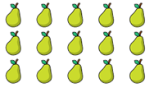  There are … columns with … in each column.  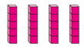  3 lots of 5 = 15  5 + 5 + 5 = 15  5 lots of 3 = 15  3 + 3 + 3 + 3 + 3 = 15 |  |  |  |  |  | I can see … × … and … ×…  3 × 5 = 15  5 × 3 = 15  3 × 5 = 5 × 3
Double  Encourage children to make links with related facts. |   Double … is …  Double 4 = 4 + 4  Double 4 is 8 | 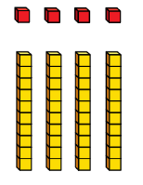  Double … is … so double … is …  Double 4 is 8  Double 40 is 80
©White Rose Education 2024 55

Multiplication

Progression of skills | Key representations
The 2 times-table | … lots of 2 = | 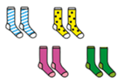  … times 2 is equal to …
 | … × 2 =
 | … × 2 = |  |  |  | 1 | 2 | 3 | 4 | 5 | 6 |  | 7 | 8 | 9 | 10
Encourage daily counting in  multiples both forwards and back. Notice that all multiples of 2 are even numbers. | 
 |  |  |  |  | 11 | 12 | 13 | 14 | 15 | 16 |  | 17 | 18 | 19 | 20
 |  |  |  |  | 21 | 22 | 23 | 24 | 25 | 26 |  | 27 | 28 | 29 | 30
1 × 2 = 2 2 = 1 × 2
2 × 2 = 4 4 = 2 × 2
3 × 2 = 6 6 = 3 × 2
 | 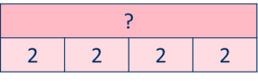 | 0 | 2 | 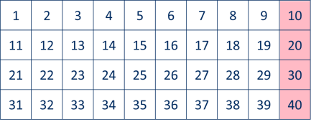  4 6 8 10 12 |  |  |  |  |  |  | 14 16 18 20 22 24
The 10 times-table | … lots of 10 = |   … times 10 is equal to …
Encourage daily counting in multiples both forwards and back. Notice the pattern in the numbers. |     … × 10 =  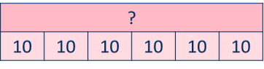   | 0 | 10 | 1 × 10 = 10  2 × 10 = 20  3 × 10 = 30  20 30 40 50 60 |  |  |  |  |  |  | 10 = 1 × 10  20 = 2 × 10  30 = 3 × 10  70 80 90 100 110 120

©White Rose Education 2024 56

Multiplication

Progression of skills | Key representations
The 5 times-table  Encourage daily counting in multiples both forwards and back. Notice the pattern in the numbers. | … lots of 5 =    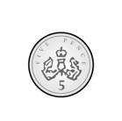    … × 5 = |  |  |  |  |  |  | … times 5 is equal to …  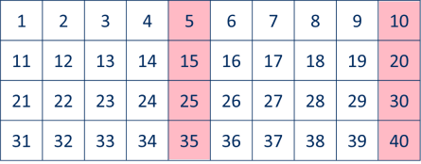  1 × 5 = 5 5 = 1 × 5  2 × 5 = 10 10 = 2 × 5  3 × 5 = 15 15 = 3 × 5  0 5 10 15 20 25 30 35 40 45 50 55 60
 |  | ?
 |  | 5 | 5 | 5 | 5 | 5
Missing numbers  Make links to known facts. | … is equal to … groups of …  18 socks, how many pairs?   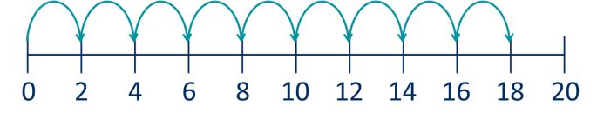 |  |  |  |  |  |  | … times … is equal to …  × 2 = 18  18 = 2 ×

©White Rose Education 2024 57

Multiplication

Year 3 | - Recall and use multiplication facts for the 3, 4 and 8 multiplication tables.  - Write and calculate mathematical statements for multiplication using the multiplication tables that they know, including for two-digit numbers times one-digit numbers, using mental and progressing to formal written methods.  - Solve problems, including missing number problems, involving multiplication, including positive integer scaling problems and correspondence problems in which n objects are connected to m objects.
Progression of skills | Key representations
The 3 times-table |   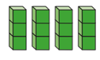  … groups of 3 = | … times 3 is equal to …  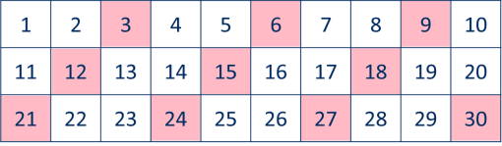  4 × 3 = 12 12 = 4 × 3  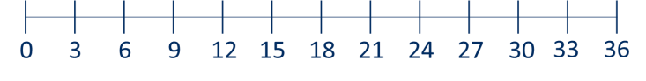
 | … × 3 =
Encourage daily counting in | 3, … times =
multiples both forwards and |   3 × … =
back.
 | 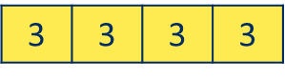
The 4 times-table  Encourage daily counting in multiples both forwards and back. Encourage children to notice links between the 2 and 4 times-tables. | … groups of 4 =  … × 4 =      4, … times =  4 × … =  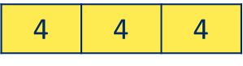 | 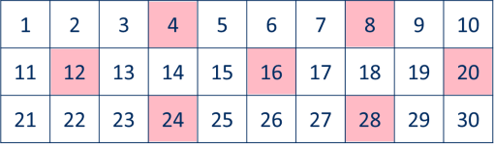  … times 4 is equal to …  3 × 4 = 12 12 = 3 × 4  0 4 8 12 16 20 24 28 32 36 | 40 44 | 48
©White Rose Education 2024 58

Multiplication

Progression of skills | Key representations
The 8 times-table  Encourage daily counting in multiples both forwards and back. Encourage children to notice links between the 2, 4 and 8 times-tables. | … lots of 8 =  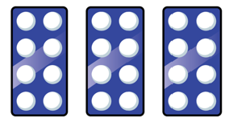  × 8 =  8, … times =  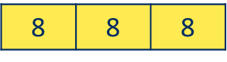  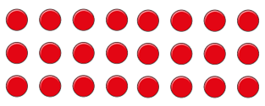  8 × … =  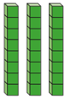 | … times 8 is equal to …  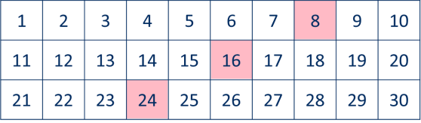  3 × 8 = 24 24 = 3 × 8  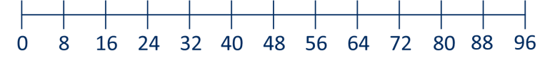
Related facts  Use knowledge of multiplying by 10 to scale times-table facts. | … × … ones is equal to … ones so … × … tens is equal to … tens.    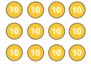  3 × 4 = 12  3 × 40 = 120
Multiply a 2-digit number by a 1-digit number - no exchange  Children apply their understanding of partitioning to represent and solve calculations using the expanded method. | … tens multiplied by … is equal to … tens.  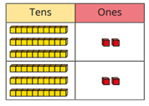  …ones multiplied by … is equal to … ones.  30 × 2 = 60  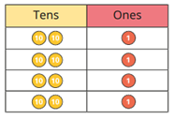  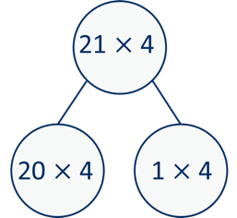  2 × 2 = 4  32 × 2 = 64
©White Rose Education 2024 59

Multiplication

Progression of skills | Key representations
Multiply a 2-digit number by a 1-digit number - with exchange  Children apply their understanding of partitioning to represent and solve calculations using the expanded method. | … tens multiplied by … is equal to … tens.  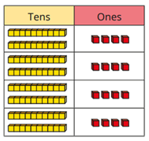  … ones multiplied by … is equal to … ones.  20 × 4 = 80 ⁴⁵ × ³  4 × 4 = 16  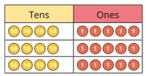  40 × 3 5 × 3  24 × 4 = 96
Scaling  Children focus on multiplication as scaling ( …. times the size) as opposed to repeated addition. | There are …. times as many … as …  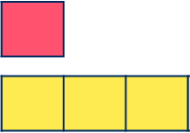  2      2 2 2      There are 3 times as many triangles as circles. | … is … times the size of …  … is … times the length/height of …  4 cm      16 cm  Miss Smith is twice the height of Jo.

©White Rose Education 2024 60

Multiplication

Progression of skills | Key representations
Correspondence problems  (How many ways?)  Encourage children to work systematically to find all the different possible combinations. | For every … , there are … possible ...    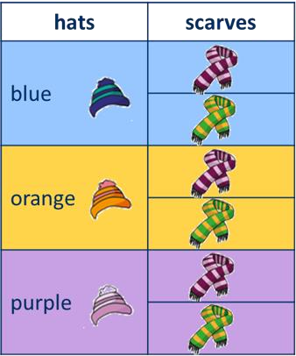  There are … × … possibilities altogether.  For every hat, there are two possible scarves.  3 × 2 = 6  There are 6 possibilities altogether.

©White Rose Education 2024 61

Multiplication

Year 4 | - Recall multiplication facts for multiplication tables up to 12 × 12  - Use place value, known and derived facts to multiply mentally, including: multiplying  by 0 and 1; multiplying together three numbers.  - Recognise and use factor pairs and commutativity in mental calculations.  - Multiply two-digit and three-digit numbers by a one-digit number using formal written  layout.  - Solve problems involving multiplying and adding, including using the distributive law to multiply two-digit numbers by one digit, integer scaling problems and harder correspondence problems such as n objects are connected to m objects.
Progression of skills | Key representations
Times-table facts to 12 × 12  Encourage daily counting in multiples both forwards and back. Encourage children to notice links between related times-tables. | 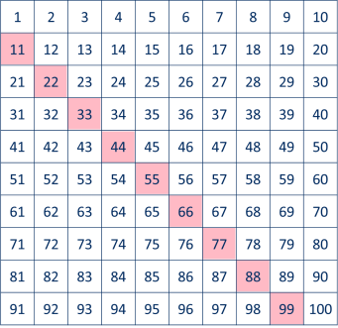  … groups of … =  … times … is equal to …  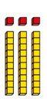  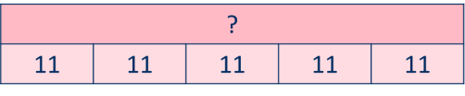  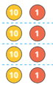  … × … =  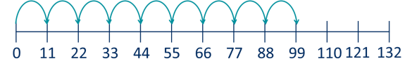
Multiply by 1 and 0 | Any number multiplied by 1 is equal to … | … × … = …
 | Any number multiplied by 0 is equal to … | 1 × 1 = 1 | 1 × 0 = 0
 |  | 2 × 1 = 2  3 × 1 = 3 | 2 × 0 = 0  3 × 0 = 0
 |  | 4 × 1 = 4 | 4 × 0 = 0
©White Rose Education 2024 62

Multiplication

Progression of skills | Key representations
Multiply 3 numbers | 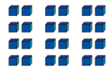  To work out … × … × …, I can first calculate … × … and then multiply the answer by …  4 × 2 × 3 = 8 × 3 = 24  2 × 3 × 4 = 6 × 4 = 24  3 × 4 × 2 = 12 × 2 = 24
Children use their
understanding of
commutativity to multiply
more efficiently.
Factor pairs | 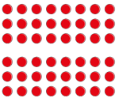  12 = | … | × | … , so … | × 12 = … × … × | 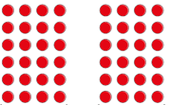  …
Children explore equivalent
calculations using different  factors pairs. |  |  |  |  | 8 × 6 = 8 × 3 × 2  8 × 6 = 24 × 2 |  |  | 6 × 8 = 6 × 4 × 2  6 × 8 = 24 × 2
Multiply by 10 and 100  Some children may over-generalise that multiplying by 10 or 100 always results in adding zeros. This will cause issues later when multiplying decimals. | When I multiply by 10, the digits move … place value column to the left.  … is 10 times the size of …  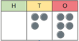  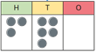 35 × 10 = 350 |  |  |  |  |  | When I multiply by 100, the digits move … place value columns to the left.  … is 100 times the size of …  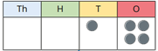  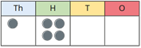 14 × 100 = 1,400
©White Rose Education 2024 63

Multiplication

Progression of skills | Key representations
Related facts  Use knowledge of multiplying by 10 and 100 to scale times-table facts. | … × … ones is equal to … ones so … × … tens is equal to … tens  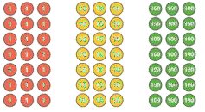  and … × … hundreds is equal to … hundreds.  3 × 7 = 21 7 × 3 = 21  3 × 70 = 210 7 × 30 = 210  3 × 700 = 2,100 7 × 300 = 2,100
Mental strategies  Partition 2 or 3-digit numbers to multiply using informal methods. | … tens multiplied by … is equal to … tens.  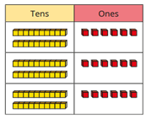  …ones multiplied by … is equal to … ones.  26  20 6  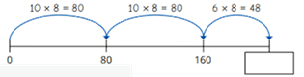  26 × 8 = 80 + 80 + 48 = 208  × 3 × 3  3 × 26 = 60 + 18 = 78 60 18

©White Rose Education 2024 64

Multiplication

Progression of skills | Key representations
Multiply a 2 or 3-digit number by a 1-digit number  The short multiplication method is introduced for the first time, initially in an expanded form. | To multiply a 2-digit number by … , I multiply the ones by … and the tens by …  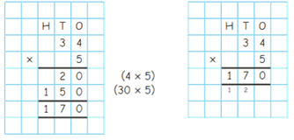  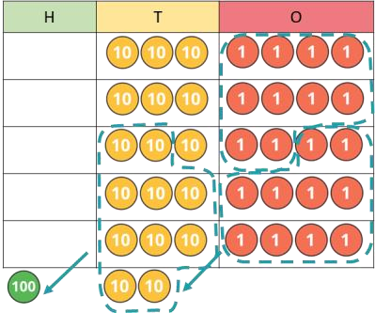  To multiply a 3-digit number by … , I multiply the ones by … , the tens by … and the hundreds by …  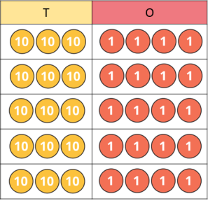
Scaling  Children focus on multiplication as scaling ( … times the size). | … is … times the size of …  7 6  7 7 7 7 7 7 6 6 6 6 6 6 6  A computer mouse costs £7 A red ribbon is 6 cm.  A keyboard costs 6 times as much. A yellow ribbon is 7 times as long.
Correspondence problems  Encourage children to use tables to show all the different possible combinations. | For every … , there are … possibilities.  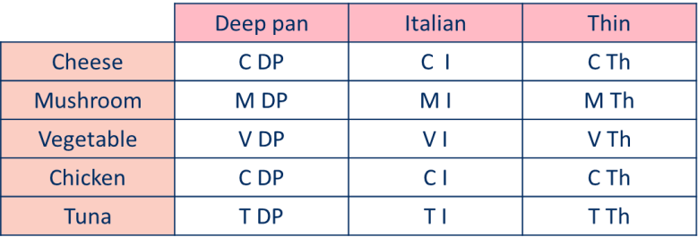  There are … × … possibilities altogether.  A pizza company offers a choice  of 5 toppings and 3 bases.  5 × 3 = 15
©White Rose Education 2024 65

Multiplication

Year 5 | - Identify multiples and factors, including finding all factor pairs of a number, and common factors of two numbers  - Recognise and use square numbers and cube numbers, and the notation for squared  (²) and cubed (³)  - Multiply numbers up to 4 digits by a one- or two-digit number using a formal written  method, including long multiplication for two-digit numbers.  - Multiply numbers mentally drawing upon known facts.  - Multiply whole numbers and those involving decimals by 10, 100 and 1000  - Multiply proper fractions and mixed numbers by whole numbers, supported by materials and diagrams.
Progression of skills | Key representations
Multiples and factors  Encourage children to notice patterns and make links with known facts. | … is a multiple of … because    … × … = … | … is a factor of … because  … × … = …  1 × 8   2 × 4  1, 2, 4 and 8 are factors of 8 |  | The common factors of … and … are …  Factors of 20 Factors of 12  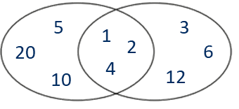
Square and cube numbers |   … squared means … × …  1 × 1 2 × 2 3 × 3 4 × 4  1² = 1 2² = 4 3² = 9 4² = 16 |  | … cubed means … × … × …  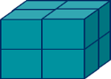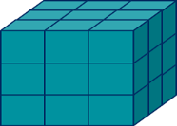  1 × 1 × 1 2 × 2 × 2 3 × 3 × 3  1³ = 1 2³ = 8 3³ = 27
©White Rose Education 2024 66

Multiplication

Progression of skills | Key representations
Multiply numbers up to 4 digits by a 1-digit number  This builds on the short multiplication method introduced in Y4 | 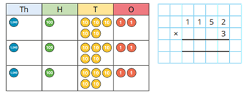  To multiply a 4-digit number by … , I multiply the ones by … , the tens by … , the hundreds by … and the thousands by …
Multiply numbers up to 4 digits by a 2-digit number  Numbers are first partitioned using an area model then long multiplication is introduced for the first time. | I can partition … into … and …  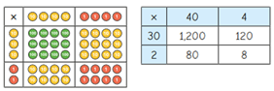  32 × 44 = 1,200 + 80 + 120 + 8  32 × 44 = 1,408 | First, I multiply by the … Then I multiply by the ...  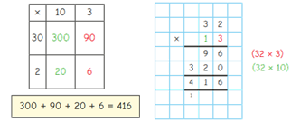

©White Rose Education 2024 67

Multiplication

Progression of skills | Key representations
Multiply by 10, 100 and  1,000  Some children may over-generalise that multiplying by a power of 10 always results in adding zeros. This will cause issues later when multiplying decimals. | To multiply by 10/100/1,000, I move all the digits … places to the left.  … is 10/100/1,000 times the size of …
 |  | M | HTh | TTh | Th | H | T | O |  | Th | H | T | O | Tth | Hth
234 × 10 = 2,340 2.34 × 10 = 23.4
234 × 100 = 23,400 2.34 × 100 = 234
234 × 1,000 = 234,000 2.34 × 1,000 = 2,340
Mental strategies  Children continue to use efficient mental strategies such as partitioning and knowledge of factor pairs and related facts to multiply. | The most efficient strategy to calculate … × … is … To calculate … × 12, I can do … × … × …  For example: 121 × 12  I could calculate 100 × 12 plus 20 × 12 plus 1 × 12  I could calculate 121 × 10 plus 121 × 2  I could calculate 121 × 6 × 2  I could calculate 121 × 4 × 3

©White Rose Education 2024 68

Multiplication

Progression of skills | Key representations
Multiply fractions by a | To multiply a fraction by an integer, I multiply the numerator by the integer and the
whole number | 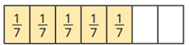  denominator remains the same.
Make links with repeated
addition.
addition. | 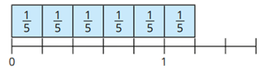  1 1 1 1 1 1 5  1 × 6 = 6 = 1 1 | 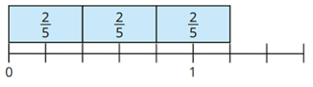  2 2 2 2  2 × 3 = 6 = 1 1 |  |  |  |  |  |  | 6
E.g. 1 × 4 = 1 + 1 + 1 + 1
5 5 5 5 5
Multiply mixed numbers by | 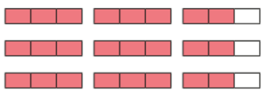  I can partition into and
a whole number
 |  | 2 2 × 3
 |  | 2 × 3 = 6 2 × 3 = 6 |  |  |  |  |  |  | = 2
 |  | 2 2 × 3 = 6 + 2 = 8

©White Rose Education 2024 69

Multiplication

Progression of skills | Key representations
Find the whole | If 1 is … , then the whole is … × … | If is … , then 1 is … and the whole is … × …  4 of = 24 1 = 24 ÷ 4 = 6  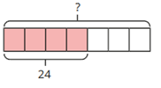  7 7  7 × 6 = 42  4 of 42 = 24  7
Children multiply to find the
whole from a given part.
 | 1 of = 6
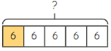
5
 | 5 × 6 = 30
 | 1 of 30 = 6
 | 5

©White Rose Education 2024 70

Multiplication
Year 6 | - Identify common factors and common multiples.  - Multiply multi-digit numbers up to 4 digits by a two-digit whole number using the formal written method of long multiplication.  - Multiply numbers by 10, 100 and 1,000  - Multiply one-digit numbers with up to two decimal places by whole numbers.  - Use their knowledge of the order of operations to carry out calculations involving the 4 operations.  - Multiply simple pairs of proper fractions, writing the answer in its simplest form.  - Solve problems involving the relative sizes of two quantities where missing values can be found by using integer multiplication and division facts.  - Solve problems involving the calculation of percentages.
Progression of skills | Key representations
Multiply numbers up to 4 digits by a 2-digit number | 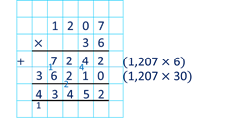  To multiply by a 2-digit number, first multiply by the ones, then multiply by the tens and then find the total.
Multiply by 10, 100 and  1,000  Some children may over-generalise that multiplying by a power of 10 always results in adding zeros. | To multiply by 10/100/1,000, I move all the digits … places to the left.  … is 10/100/1,000 times the size of …  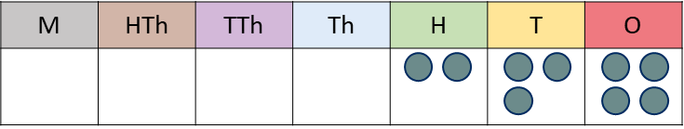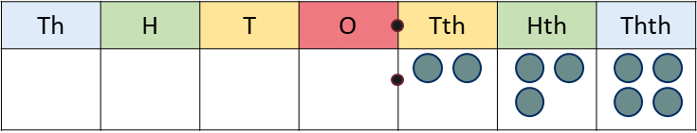  234 × 10 = 2,340 0.234 × 10 = 2.34  234 × 100 = 23,400 0.234 × 100 = 23.4  234 × 1,000 = 234,000 0.234 × 1,000 = 234
©White Rose Education 2024 71

Multiplication

Progression of skills | Key representations
Order of operations  Calculations in brackets should be done first.  Multiplication and division should be performed before addition and subtraction. | … has greater priority than …, so the first part of the calculation I need to do is …  (3 + 4) × 2 = 14 3 + 4 × 2 = 11  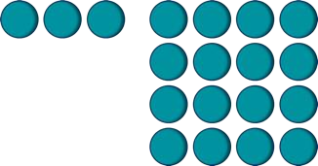  3 + 4² = 19
Multiply decimals by integers  This is the first time children multiply decimals by numbers other than 10, 100  or 1,000  Encourage them to make links with known facts and whole number multiplication. | I know that … × … = …,  so I also know that … × … = …  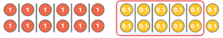  6 × 2 = 12 6 × 0.2 = 1.2 | I need to exchange 10 … for 1 …  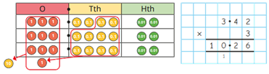  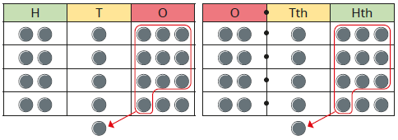  213 × 4 = 852 2.13 × 4 = 8.52

©White Rose Education 2024 72

Multiplication

Progression of skills | Key representations
Multiply fractions by | When multiplying a pair of fractions, I need to multiply the numerator and multiply the
fractions | denominator.
Encourage children to give
answers in their simplest
form.
 |  | 1 1 1 |  |  |  |  |  | 2 4 8 |  |  |  |  |  | 2 3 6 2
 |  | 3 × 5 = 15 |  |  |  |  |  | 3 × 5 = 15 |  |  |  |  |  | 3 × 5 = 15 = 5
Find the whole | If 1 is … , then the whole is … × … |  |  |  |  |  |  |  |  |  |  |  |  | If is … , then 1 is … and the whole is … × …  4 of = 48  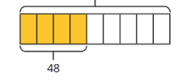  9 1 = 48 ÷ 4 = 12  9  ?  9 × 12 = 108  4  9 of 108 = 48
Children multiply to find the
whole from a given part. | 1 of = 18  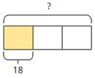  3
 | 18 × 3 = 54
 | 1 of 54 = 18
 | 3

©White Rose Education 2024 73

Multiplication

Progression of skills | Key representations
Calculate percentages | There are … lots of … % in 100% To find … %, I need to divide by … | … % is made up of … %, and … %
Children first learn how to find 1%, 10%, 20%, 25% and 50% before using multiples of these amounts to find any percentage. | 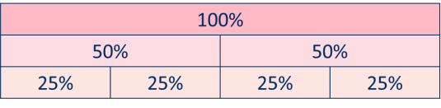  50% of … = …÷ 2  25% of … = …÷ 4 | 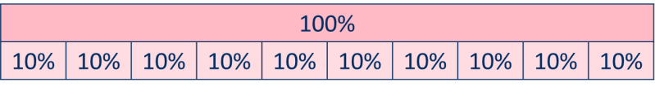  To find 30%, I can find 10% and then multiply it by 3 To find 23%, I can use 10% × 2 and 1% × 3  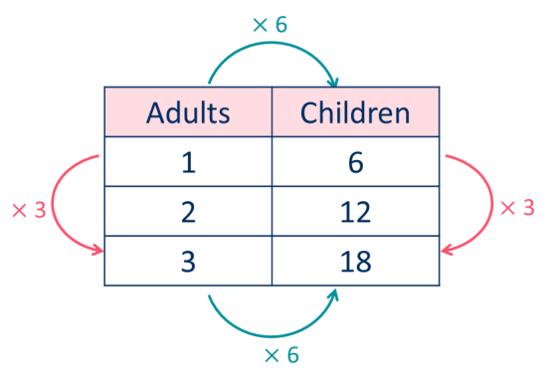  To find 99%, I can find 1%, then subtract from 100%
Calculations involving ratio | 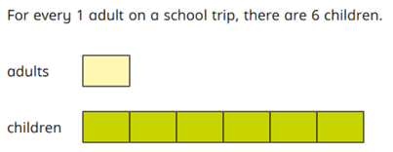  For every … , there are … |  | 0 |  | 1 |  | 2 |  | 3 |  | 4 |  | 5 |  | 6
Encourage children to see
the multiplicative
relationship between ratios.
They will need to multiply
or divide each value by the
same number to keep the
ratio equivalent.
Double number lines and
ratio tables help children to
see both horizontal and
vertical multiplicative  relationships. | Adults  Children
vertical multiplicative  relationships. |  |  | 0 |  | 6 |  | 12 |  | 18

©White Rose Education 2024 74

Progression of skills - Division

Year group | Skill
Reception | - Sharing  - Grouping
Year 1 | - Make equal groups – grouping  - Make equal groups – sharing  - Find a half  - Find a quarter

©White Rose Education 2024 75

Progression of skills - Division

Year group | Skill
Year 2 | - Divide by 2  - Divide by 10  - Divide by 5  - Missing numbers  - Unit fractions  - Non-unit fractions
Year 3 | - Divide by 3  - Divide by 4  - Divide by 8  - Related facts  - Divide a 2-digit number by a 1-digit number - no exchange  - Divide a 2-digit number by a 1-digit number - with remainders  - Unit fractions of a set of objects  - Non-unit fractions of a set of objects

©White Rose Education 2024 76

Progression of skills - Division

Year group | Skill
Year 4 | - Division facts to 12 × 12  - Divide a number by 1 and itself  - Related facts  - Divide a 2 or 3-digit number by a 1-digit number  - Divide by 10 and 100
Year 5 | - Mental strategies  - Divide numbers up to 4 digits by a 1-digit number  - Divide by 10, 100 and 1,000  - Fraction of an amount

©White Rose Education 2024 77

Progression of skills - Division

Year group | Skill
Year 6 | - Short division  - Mental strategies  - Long division  - Order of operations  - Divide by 10, 100 and 1,000  - Divide decimals by integers  - Decimal and fraction equivalents  - Divide a fraction by an integer  - Fraction of an amount  - Calculate percentages  - Calculations involving ratio

©White Rose Education 2024 78

Division

Reception | - Have a deep understanding of number to 10, including the composition of each number.  - Subitise (recognise quantities without counting) up to 5  - Automatically recall (without reference to rhymes, counting or other aids) number bonds up to 5 and some number bonds to 10, including double facts.  - Explore and represent patterns within numbers up to 10, including evens and odds, double facts and how quantities can be distributed equally.
Progression of skills | Key representations
Sharing  Provide practical activities such as sharing items during snack time. Encourage children to check whether items have been shared fairly (equally). | There are … altogether.  They are shared equally between … groups.  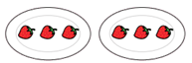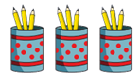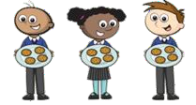
Grouping  Provide opportunities to make equal groups when tidying up or during snack time. Encourage children to check that each group has the same amount. | There are … groups of … There are … altogether.

©White Rose Education 2024 79

Division

Year 1 | - Solve simple one-step problems involving division, using concrete objects, pictorial representations and arrays with the support of the teacher.  - Recognise, find and name a half as one of two equal parts of a quantity.  - Recognise, find and name a quarter as one of four equal parts of an object, shape or quantity.
Progression of skills | Key representations
Make equal groups - grouping  Encourage children to physically move objects into equal groups. They can also circle equal groups when using pictures. | There are … altogether. How many groups of … can you make?  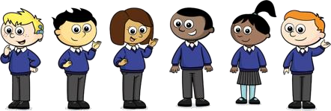   | Circle groups of 2  There are … groups of 2  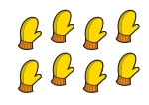 |  | Take … cubes.  Make equal groups.  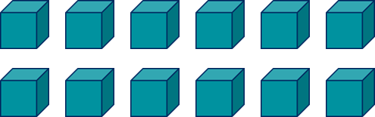  There are … groups of …
Make equal groups – sharing  Encourage children to check that the objects have been shared fairly and each group is the same. | … have been shared equally between… There are … on/in each …  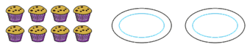   |  | Take … cubes.  Share them between …  12 shared between … is …

©White Rose Education 2024 80

Division

Progression of skills | Key representations
Find a half  Start with practical opportunities to share a quantity into 2 groups. Progress to circling half of the objects in a picture and then to finding the whole from a given half. | To find half, I need to share  into 2 equal groups.  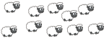  There are … in each group. | Half of … is …     | If … is half, what is the  whole?  4 is half of …
Find a quarter  Start with practical opportunities to share a quantity into 4 groups. Progress to using pictures or bar models to find a quarter and then to finding the whole from a given quarter. | To find a quarter, I need to share into 4 equal groups.  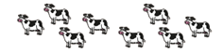  There are … in each group. | A quarter of … is …    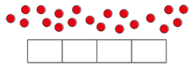 | If … is one quarter, what is the whole?  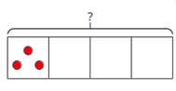  3 is one quarter of …

Division

Year 2 | - Recall and use division facts for the 2, 5 and 10 multiplication tables.  - Calculate mathematical statements for division within the multiplication tables and  write them using the division (÷) and equals (=) signs.  - Recognise, find, name and write fractions 1 , 1 , 2 and 3 of a quantity.  3 4 4 4
Progression of skills | Key representations
Divide by 2 | There are … equal groups of 2  … ÷ 2 = … | … shared equally between 2 is … Half of … is …  … ÷ 2 = …        4 × 2 = 8  8 ÷ 2 = 4  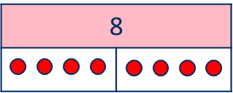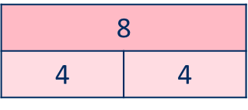
Encourage children to  compare the grouping and sharing structures of division and to make links with times-table facts and halving. | 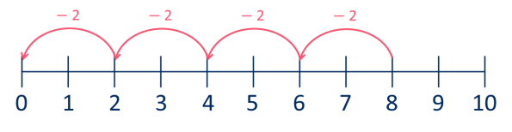      4 × 2 = 8  8 ÷ 2 = 4
Divide by 10 | There are … equal groups of 10 | … shared equally between 10 is …
 | … ÷ 10 = … | … ÷ 10 = …
Encourage children to  compare the grouping and sharing structures of | 6 × 10 = 60  60 ÷ 10 = 6 | 6 × 10 = 60  60 ÷ 10 = 6
division and to make links  with times-table facts. | − 10 − 10 − 10 − 10 − 10 − 10  
division and to make links  with times-table facts. |  |  | 60
division and to make links  with times-table facts. |  |  | 6 | 6 | 6 | 6 | 6 | 6 | 6 | 6 | 6 | 6
 | 0 10 20 30 40 50 60 70 80 90 100
©White Rose Education 2024 82

Division

Progression of skills | Key representations
Divide by 5 | There are … equal groups of 5  … ÷ 5 = … | … shared equally between 5 is …  … ÷ 5 = …
Encourage children to  compare the grouping and sharing structures of division and to make links with times-table facts. |     6 × 5 = 30  30 ÷ 5 = 6  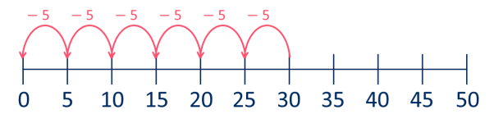 |   6 × 5 = 30    30 ÷ 5 = 6
 |  |  | 30
 |  |  | 
Missing numbers | 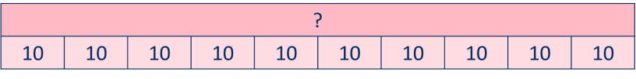  … divided by 2/5/10 is equal to …
Bar models are useful to  show the link between | 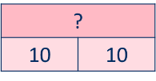  ÷ 2 = 10
multiplication and division. | 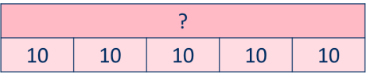  ÷ 5 = 10
 |  |  |  |  | ÷ 10 = 10

©White Rose Education 2024 83

Division

Progression of skills | Key representations
Unit fractions  In Y2 the focus is on finding 1 , 1 and 1  2 4 3  Bar models are useful to  show the link between division and finding a fraction. | The objects have been shared fairly into … groups.  1 of … is ... |  |  |  |  |  |  |  | There are … equal parts. There is … part circled.  1 is circled.  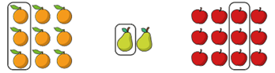
 |  | 
Non-unit fractions  In Y2 the focus is on finding 2 and 3  4 4  Prompt children to notice that 2 is equivalent to 1  4 2 | The objects have been shared fairly into …  groups. |  |  |  |  |  |  |  | There are … equal parts.  There are … parts circled.  is circled.  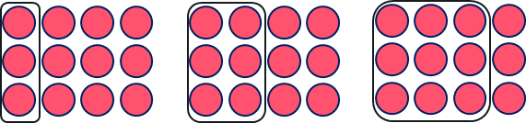
 | of … is ...

©White Rose Education 2024 84

Division

Year 3 | - Recall and use division facts for the 3, 4 and 8 multiplication tables.  - Write and calculate mathematical statements for division using the multiplication tables that they know, including for two-digit numbers times one-digit numbers, using mental and progressing to formal written methods.  - Recognise, find and write fractions of a discrete set of objects: unit fractions and non-  unit fractions with small denominators.
Progression of skills | Key representations
Divide by 3 | There are … groups of 3 in …  … ÷ 3 = | … has been shared equally into 3 equal groups.  … ÷ 3 =
Encourage children to  compare the grouping and sharing structures of division and to make links with times-table facts. |   2 × 3 = 6          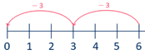  6 ÷ 3 = 2 |   2 × 3 = 6        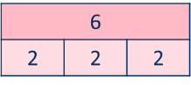  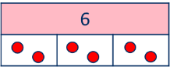  6 ÷ 3 = 2
Divide by 4 | There are … groups of 4 in … | … has been shared equally into 4 equal groups.
Encourage children to compare the grouping and |           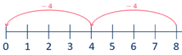  … ÷ 4 =  2 × 4 = 8  8 ÷ 4 = 2 | … ÷ 4 =  
sharing structures of  division and to make links with times-table facts. |  |   2 × 4 = 8      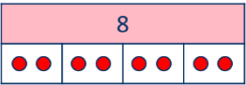  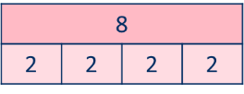    8 ÷ 4 = 2

©White Rose Education 2024 85

Division

Progression of skills | Key representations
Divide by 8 | There are … groups of 8 in …  … ÷ 8 = | … has been shared equally into 8 equal groups.  … ÷ 8 =
Encourage children to  compare the grouping and sharing structures of division and to make links with times-table facts. |   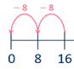  2 × 8 = 16  16 ÷ 8 = 2     | 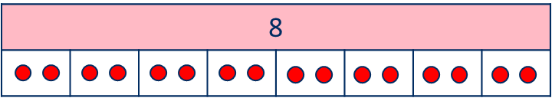                                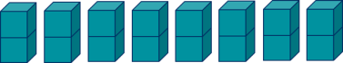  2 × 8 = 16  16 ÷ 8 = 2
Related facts  Link to known times-table facts. | … ÷ … is equal to …,  so … tens ÷ … is equal to … tens. |  | 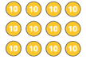 | 12 ÷ 3 = 4  120 ÷ 3 = 40
Divide a 2-digit number by | … tens divided by … is equal to … tens.  … ones divided by … is equal to … ones.  60 ÷ 2 = 30  4 ÷ 2 = 2  64 ÷ 2 = 32 |  | 84 ÷ 4  80 ÷ 4 4 ÷ 4
a 1-digit number - no
exchange
Partition into tens and ones
to divide and then
recombine.

©White Rose Education 2024 86

Division

Progression of skills | Key representations
Divide a 2-digit number by a 1-digit number - with remainders  Encourage children to partition numbers flexibly to help them to divide more efficiently. | … tens divided by … is equal to … tens.  … ones divided by … is equal to … ones.  96 ÷ 4  80 ÷ 4 16 ÷ 4  80 ÷ 4 = 20  16 ÷ 4 = 4  96 ÷ 4 = 24 | There are … groups of …  There are … remaining.  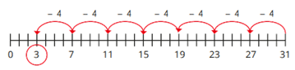  31 ÷ 4 = 7 r3  94 ÷ 4 = 23 r2  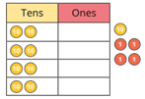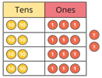
Unit fractions of a set of objects  Bar models are useful to show the link between division and fractions, for example, dividing by 3 and finding a third. | The whole is divided into … equal parts.  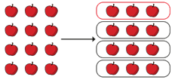  Each part is 1 of the whole.  1  4 of 12 apples is 3 apples. | One … of … is …
1 of 12 is 3
4
1

3 of 36 is 12

©White Rose Education 2024 87

Division

Progression of skills | Key representations
Non-unit fractions of a set  of objects  Bar models are a useful representation and show the links with division and multiplication. | The whole is divided into … equal parts.  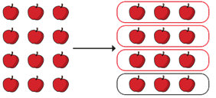  Each part is 1 of the whole.  3 of 12 apples is 9 apples.  4 | 1 of … is …, so of … is …  3 of 12 is 9
 |  | 4
2 of 36 is 24
3

©White Rose Education 2024 88

Division

Year 4 | - Recall division facts for multiplication tables up to 12 × 12  - Use place value, known and derived facts to divide mentally, including: dividing by 1  - Find the effect of dividing a one- or two-digit number by 10 and 100, identifying the value of the digits in the answer as ones, tenths and hundredths.
Progression of skills | Key representations
Division facts to 12 × 12 | There are … groups of … in …  … ÷ … =      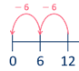  2 × 6 = 12  12 ÷ 6 = 2 | … has been shared equally into … equal groups.        … ÷ … =
Encourage children to
compare the grouping and sharing structures of division and to make links with times-table facts.
 |  |  |           12 |  |  |  |  |  | 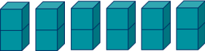  2 × 6 = 12  12 ÷ 6 = 2
Divide a number by 1 and itself | When I divide a number by 1, the number remains the same. | When I divide a number by itself, the answer is 1
Children may try to divide a number by zero and it should be highlighted that this is not possible. | 5 shared between 1 is 5   There are 5 groups of 1 in 5   | 5 shared between 5 is 1    There is 1 group of 5 in 5

©White Rose Education 2024 89

Division

Progression of skills | Key representations
Related facts | … ÷ … is equal to …
Link to known times-table facts. | so … tens ÷ … is equal to … tens  and … hundreds ÷ … is equal to … hundreds.
 | 21 ÷ 7 = 3 |  | 21 ÷ 3 = 7
 | 210 ÷ 7 = 30 |  | 210 ÷ 3 = 70
 | 2,100 ÷ 7 = 300 |  | 2,100 ÷ 3 = 700
Divide a 2 or 3-digit | I can partition … into … tens and … ones.  84 ÷ 4  80 ÷ 4 = 20  4 ÷ 4 = 1  80 ÷ 4 4 ÷ 4 84 ÷ 4 = 21  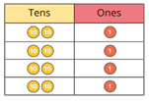 | I cannot share the hundreds/tens equally, so I need to
number by a 1-digit |  | 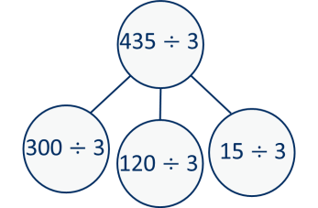  exchange 1 … for 10 …
number |  | 300 ÷ 3 = 100
Progress from divisions with no exchange, to divisions  with exchange and then |  | 120 ÷ 3 = 40  15 ÷ 3 = 5  435 ÷ 3 = 145
divisions with remainders. |  | 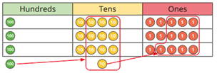

©White Rose Education 2024 90

Division

Progression of skills | Key representations
Divide by 10 and 100  Encourage children to notice that dividing by 100 is the same as dividing by 10 twice. | When I divide by 10, the digits move 1 place value column to the right.  … is one-tenth the size of … |  |  |  |  | When I divide by 100, the digits move 2 place value columns to the right.  … is one-hundredth the size of …
 |  | O | Tth | 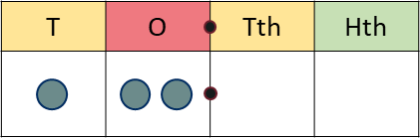  Hth |  |  | O | Tth | Hth
 | 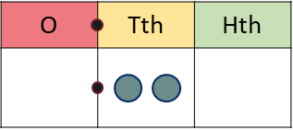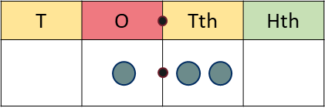  2 ÷ 10 = 0.2 12 ÷ 10 = 1.2 |  |  |  |  | 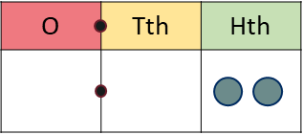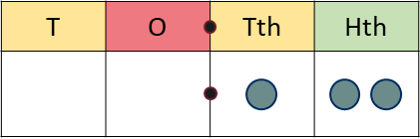  2 ÷ 100 = 0.02 12 ÷ 100 = 0.12

©White Rose Education 2024 91

Division

Year 5 | - Divide numbers mentally drawing upon known facts.  - Divide numbers up to 4 digits by a one-digit number using the formal written method  of short division and interpret remainders appropriately for the context.  - Divide whole numbers and those involving decimals by 10, 100 and 1,000
Progression of skills | Key representations
Mental strategies | I can partition … into … and  … to help me to divide more easily.  436 ÷ 4  400 ÷ 4 36 ÷ 4 | 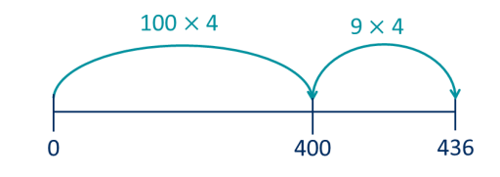  I can show groups of … on a number line. | To divide by …, I can divide by … and then divide the result by …  436 ÷ 4 = 436 ÷ 2 ÷ 2  436 ÷ 2 = 218  218 ÷ 2 = 109
Divide numbers up to 4 digits by a 1-digit number  The short division method is introduced for the first time. | 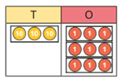  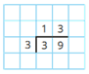  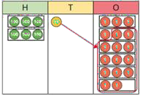  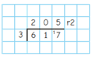  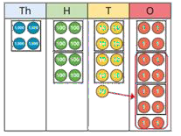  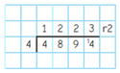  There are … groups of … hundreds/tens/ones/ in … I can exchange 1 … for 10 …
©White Rose Education 2024 92

Division

Progression of skills | Key representations
Divide by 10, 100 and 1,000  Encourage children to notice that dividing by 100 is the same as dividing by 10 twice, and that dividing by 1,000 is the same as dividing by 10 three times. | To divide by 10/100/1,000, I move all the digits … places to the right.  … is one-tenth/one-hundredth/one-thousandth the size of …  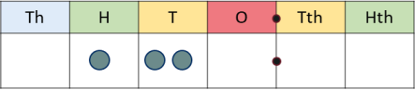  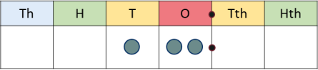 120 ÷ 10 = 12  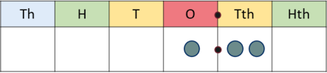 120 ÷ 100 = 1.2  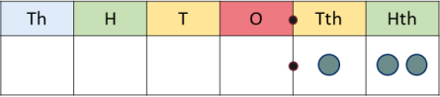 120 ÷ 1,000 = 0.12
Fraction of an amount  Bar models support children to understand that to find a fraction of an amount, we divide by the denominator and multiply by the numerator. | To find of … , I need to divide by … and multiply by …  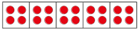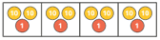  1 1  of 20 = of 84 =  5 4  3 3  of 20 = of 84 =  5 4 | 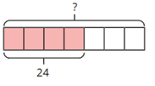  If 1 is … , then the whole is … × …  1 of = 6  5  4  7 of = 24

©White Rose Education 2024 93

Division

Year 6 | - Perform mental calculations, including with mixed operations and large numbers.  - Divide numbers up to 4 digits by a two-digit whole number using the formal written method of long division, and interpret remainders as whole number remainders, fractions, or by rounding, as appropriate for the context.  - Divide numbers up to 4 digits by a two-digit number using the formal written method  of short division where appropriate, interpreting remainders according to the context.  - Divide numbers by 10, 100 and 1,000 giving answers up to three decimal places.  - Use written division methods in cases where the answer has up to two decimal places.  - Associate a fraction with division and calculate decimal fraction equivalents.  - Divide proper fractions by whole numbers [for example, 1 ÷ 2 = 1 ]  3 6  - Solve problems involving the calculation of percentages.
Progression of skills | Key representations
Short division  Encourage children to interpret remainders in context, for example  knowing that “4 remainder 1” could mean 4 complete boxes with 1 left over so 5 boxes will be needed. | There are … groups of … hundreds/tens/ones/ in …  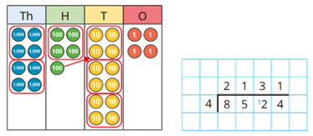  I can exchange 1 … for 10 …

©White Rose Education 2024 94

Division

Progression of skills | Key representations
Mental strategies  Include partitioning and number line strategies outlined in Y5 as well as division using factors. | To divide by … , I can first divide by … and then divide the answer by …  240 ÷ 60 = 240 ÷ 10 ÷ 6 9,120 ÷ 15 = 9,120 ÷ 5 ÷ 3  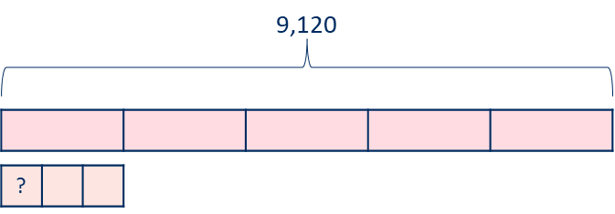  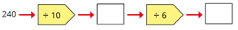  480 ÷ 24 = 480 ÷ 4 ÷ 6  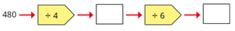
Long division  The long division method is introduced for the first time. Two alternative methods are shown. | 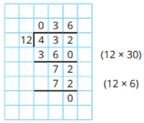  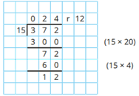  Method 1 | Method 2  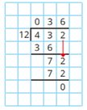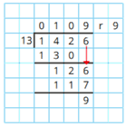
Order of operations Calculations in brackets should be done first, then powers. Multiplication and division should be performed before addition and subtraction. | … has greater priority than …, so the first part of the calculation I need to do is …    (6 + 4) ÷ 2 = 5 6 + 4 ÷ 2 = 8
©White Rose Education 2024 95

Division

Progression of skills | Key representations
Divide by 10, 100 and 1,000 Encourage children to notice that dividing by 100 is the same as dividing by 10 twice, and that dividing by 1,000 is the same as dividing by 10 three times. | 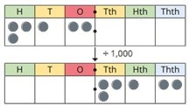  To divide by … , I move the digits … places to the right.  312 ÷ 10 = 31.2 906 ÷ 10 = 90.6  312 ÷ 100 = 3.12 906 ÷ 100 = 9.06  312 ÷ 1,000 = 0.312 906 ÷ 1,000 = 0.906
Divide decimals by integers  This is the first time children divide decimals by numbers other than 10, 100 or 1,000 | I know that … ÷ … = …,  so I also know that … ÷ … = …  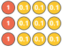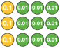  39 ÷ 3 = 13 3.9 ÷ 3 = 1.3 0.39 ÷ 3 = 0.13 | 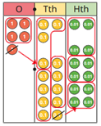  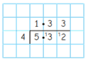  I need to exchange 1 … for 10 …
Decimal and fraction equivalents | The fraction … is equivalent to the decimal …  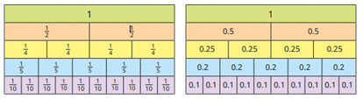  1 = 0.2 2 = 0.4 3 = 0.6  5 5 5 | is equal to 100  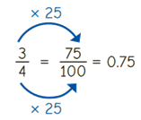
©White Rose Education 2024 96

Division

Progression of skills | Key representations
Divide a fraction by an integer  This is the first time children divide fractions by an integer. | … ones divided by 2 is … ones so … sevenths divided by 2 is  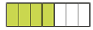  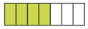  … sevenths.  4 ÷ 4 = 1  7 7  4 ÷ 2 = 2  7 7 | 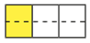  I am dividing by … , so I can split each part into … equal parts.  1 ÷ 2 = 1  3 6 | … is equivalent to … so … ÷ … = … ÷ …  2 = 4  3 6  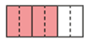  so 2 4 1  3 ÷ 4 = 6 ÷ 4 = 6
Fraction of an amount  Children divide and multiply to find fractions of an amount. Bar models can still be used to support understanding where needed. | To find 1 I divide by …  1  2 of 36 = 36 ÷ 2  1  of 36 = 36 ÷ 12  12 | If 1 is equal to …, then are  equal to …  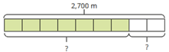  7 1  9 of 2,700 = 9 of 2,700 × 7 | If is equal to …, then the  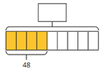  whole is equal to …  4  9 of = 48

©White Rose Education 2024 97

Division

Progression of skills | Key representations
Calculate percentages  Children first learn how to find 1%, 10%, 20%, 25% and 50% before using multiples of these amounts to find any percentage. | There are … lots of … % in 100% To find … %, I need to divide by …  50% of … = …÷ 2  25% of … = …÷ 4 | … % is made up of … %, and … %  To find 30%, I can find 10% and then multiply it by 3 To find 23%, I can use 10% × 2 and 1% × 3  To find 99%, I can find 1%, then subtract from 100%
Calculations involving ratio  Encourage children to see the multiplicative relationship between ratios. They will need to multiply or divide each value by the same number to keep the ratio equivalent.  Double number lines and ratio tables help children to see both horizontal and vertical multiplicative relationships. | For every … , there are … |  |  |  |  |  |  |  |  | ÷ 6
 | 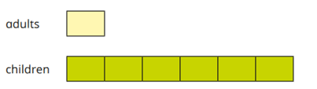  For every 6 children on a school trip, there is 1 adult. |  | ÷ 3 |  |  | Adults |  |  |  |  | Children |  |  |  |  | ÷ 3
 |  |  |  |  |  | 1 |  |  |  |  | 6
 |  |  |  |  |  | 2 |  |  |  |  | 12
 |  |  |  |  |  | 3 |  |  |  |  | 18
 | 0 |  |  |  |  | 1 |  | 2 |  | ÷ 6  3 |  |  | 4 |  | 5 | 6
Adults
Children
 | The ratio of children to adults is 6 : 1 |  |  | 0 |  | 6 |  | 12 |  | 18

©White Rose Education 2024 98

